

**Abstract:**

You hopefully have heard about the z/OS Installation Strategy? This is an undertaking that is across the entire z/OS industry (with strong participation from both IBM and ISVs) to provide a common installation and packaging method that you use from z/OSMF.

This self-directed lab will take you through each step needed to install a Portable Software Instance, PSI, from the point of view of a z/OS customer.

So, you’ve bought a great new product called “The Box III” from Hooli! You’ve acquired the file (somehow, possibly via GIMGTPKG), and if necessary, also un-archived it into your z/OS UNIX file system (if you received it as a single pax archive file). What’s next? A very simple deployment with z/OSMF Software Management.

*What level of z/OSMF do you need to package or install a PSI? Ensure you have the appropriate z/OSMF Software Management support installed:*

* *z/OSMF V2.2 with PTF UI44516 , or*
* *z/OSMF V2.1 with PTF UI42018*

Note: Subsequent enhancements are being made to z/OSMF Software Management all the time. To find them, just use the SMP/E FIXCAT IBM.DrivingSystem-RequiredService.Note: Subsequent enhancements are being made to z/OSMF Software Management all the time. To find them, just use the SMP/E FIXCAT IBM.DrivingSystem-RequiredService. Note: Subsequent enhancements are being made to z/OSMF Software Management all the time. To find them, just use the SMP/E FIXCAT IBM.DrivingSystem-RequiredService. The Exercise instructions heading should use paragraph style ***Heading 2 (new page)***.

You can start a new part of the exercise with an introductory paragraph, or jump directly to the steps required to complete the part.

When composing exercise steps make sure you start with a major numbered step using style ***Steps***. This numbered step describes what will be done. Experienced students can attempt to complete this step just by reading and doing what’s in the numbered step. Follow with lettered steps which describe in detail how to accomplish the major step. These minor steps are also of style ***Steps***, but are indented using the tab key, or the indent buttons on the toolbar.

See the example below:

When you follow this self-directed lab, here is a high-level overview of what you will learn:

1. Logon to z/OSMF with your supplied lab id and password.
2. z/OS Customer view: install a PSI provided from a software vendor using z/OSMF Software Management’s deployment task.

Logon to z/OSMF.

#1a

In this step, we will now go into z/OSMF to use the Workflow Editor function. For this lab, we are using a z/OSMF 3.1 system.

1. Go to <https://share.centers.ihost.com/zosmf/> on the Firefox or IE web browser. (If you want to follow this lab on your own system, that is fine. Just not some of the samples we use you will need to supply yourself, using the Appendix to find those samples.).
2. Using the userid you were given (SHARAnn, SHARBnn, or SHARCnn) and the password, logon to z/OSMF. The userid you were given is a regular z/OS userid on this system and has been given access to z/OSMF. There is *no* z/OSMF code on this workstation, all executables (except the web browser) is on the z/OS system.
3. Click on “LOG IN”.

**https://share.centers.ihost.com/zosmf/**

#1a

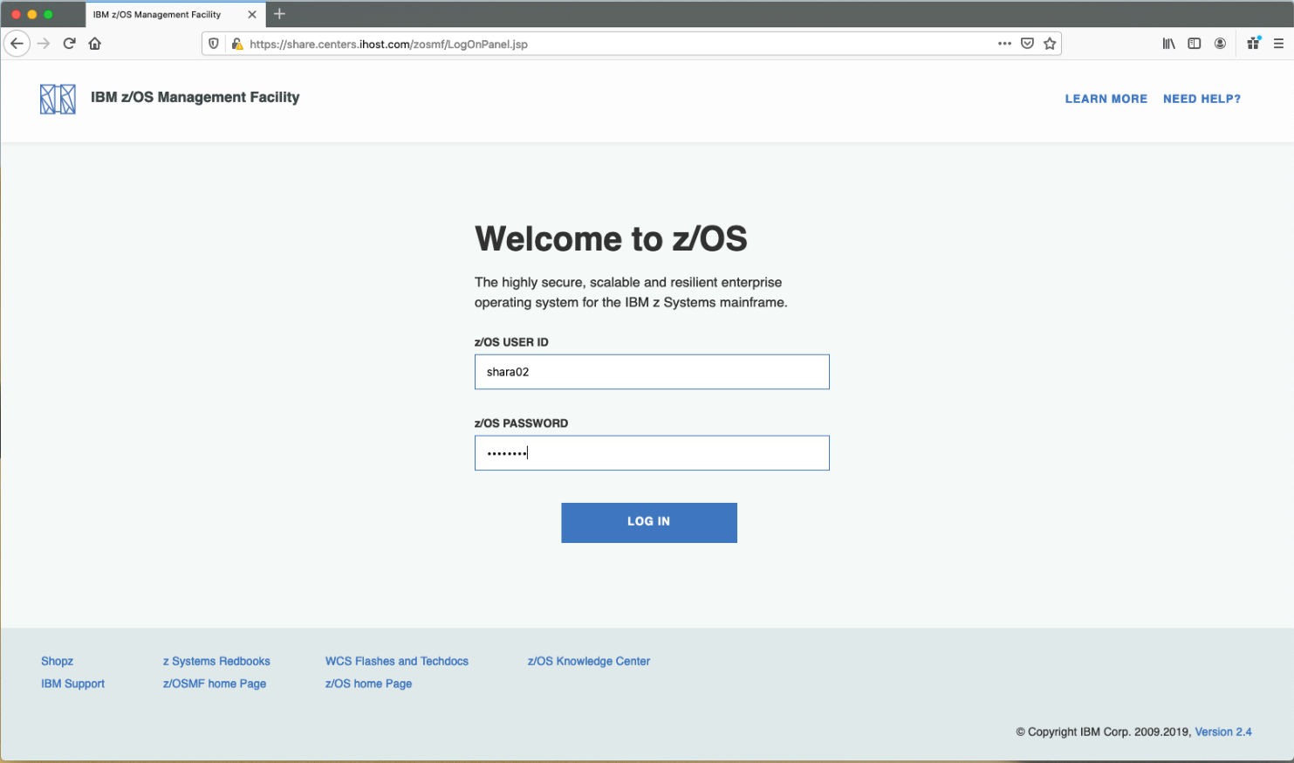

#1c

#1b

Click on “**Software Management**”.

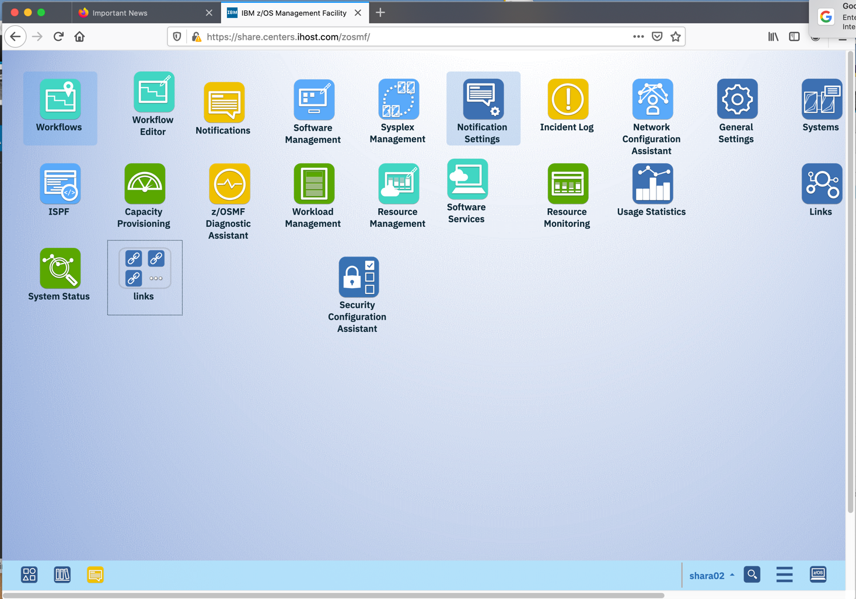

Click on “**Portable Software Instances**”.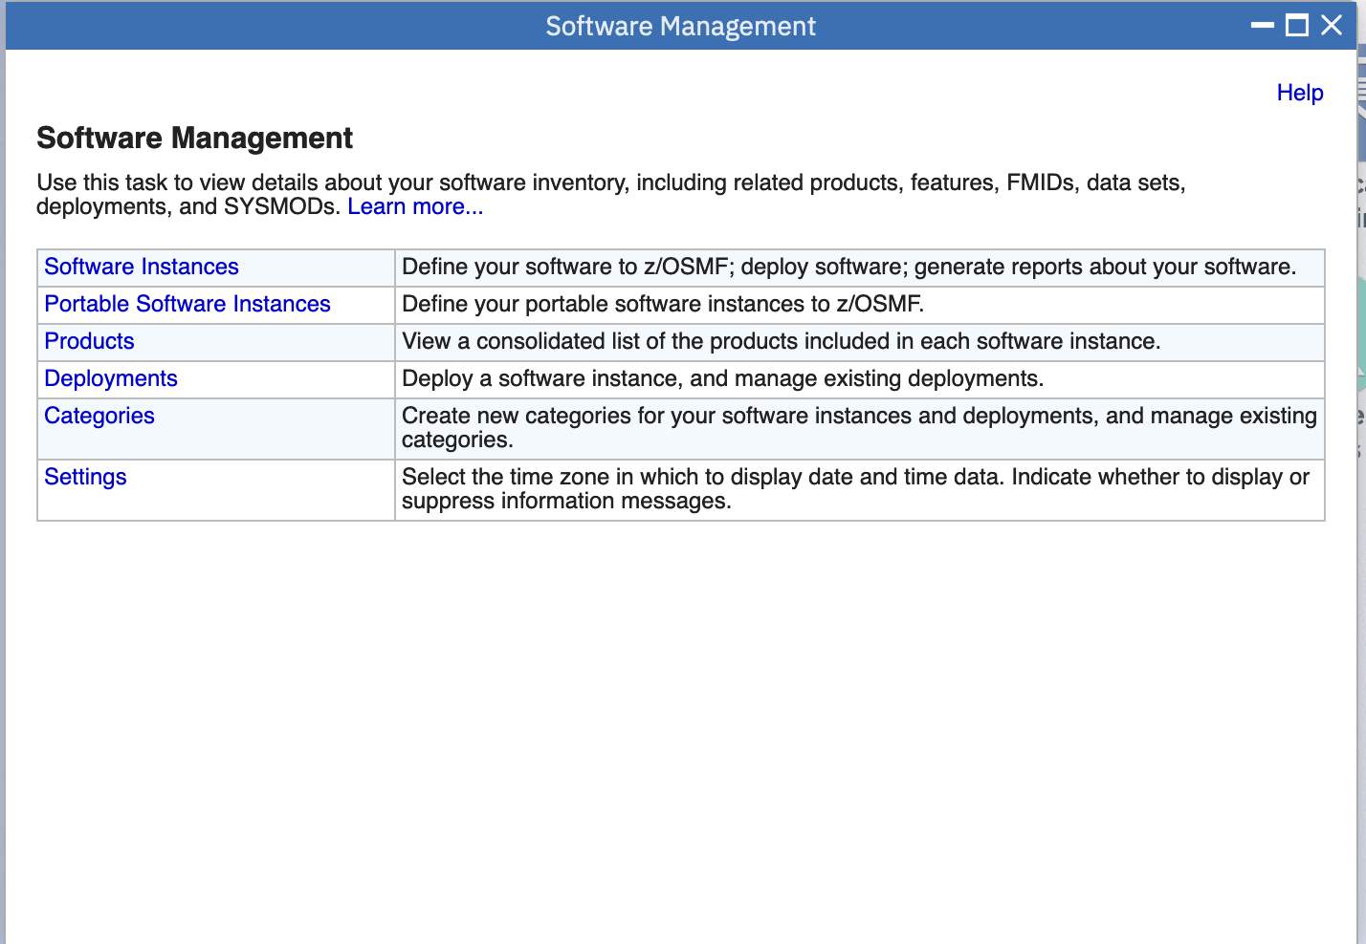

This is where all the Portable Software Instances (PSI) on this system can be found.

Now we will add a PSI (portable software instance) to the inventory for installing.

Go to **Actions -> Add -> From z/OSMF system**. You are going to add your PSI to the inventory for installing.

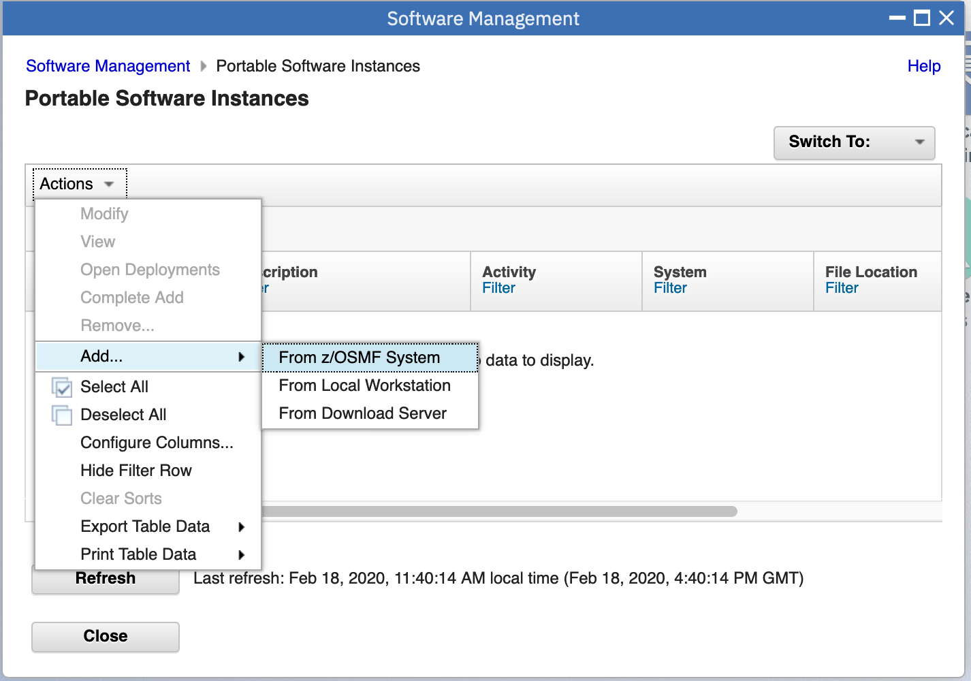

On the next screen, select the **System** as **S2** (there might be another choice, so make sure you select **S2**) and then provide the z/OS UNIX location **/u/mwalle/zosmf/labs**

Click on **Retrieve.**

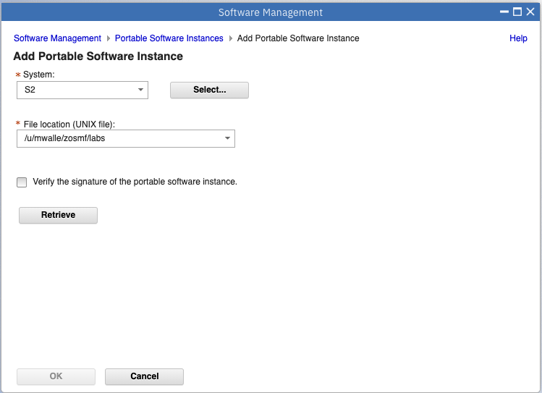

It might take a moment or two:

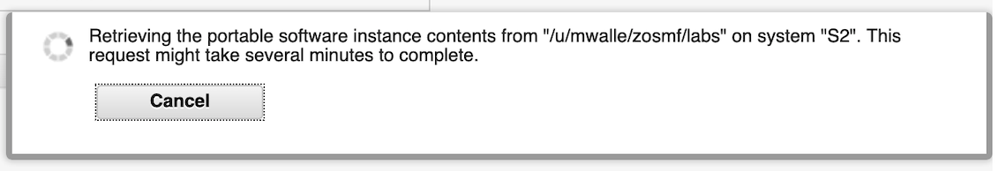

When it has been successfully retrieved, you’ll see some information (that the product was packaged with) in the PSI. Add your USERID to the Name. Click on **OK.**

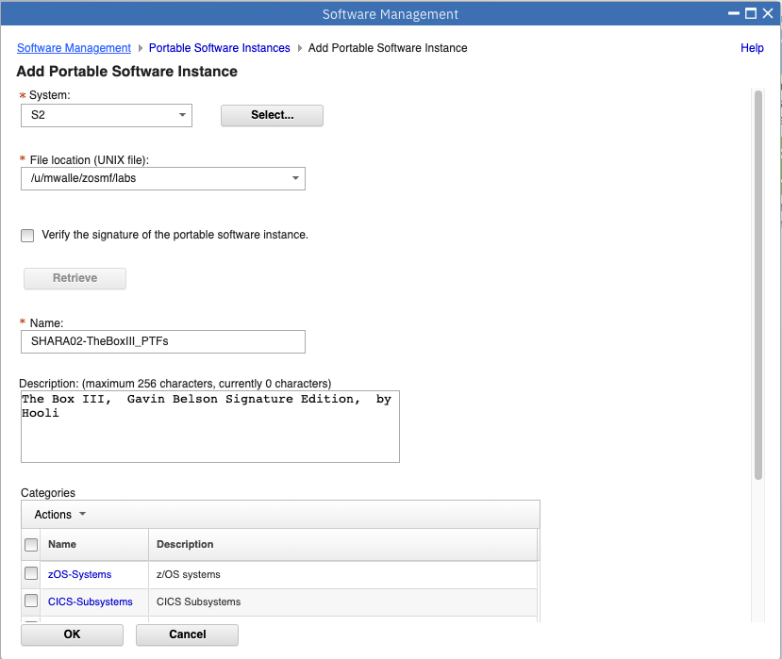

Your PSI is ready to be installed!

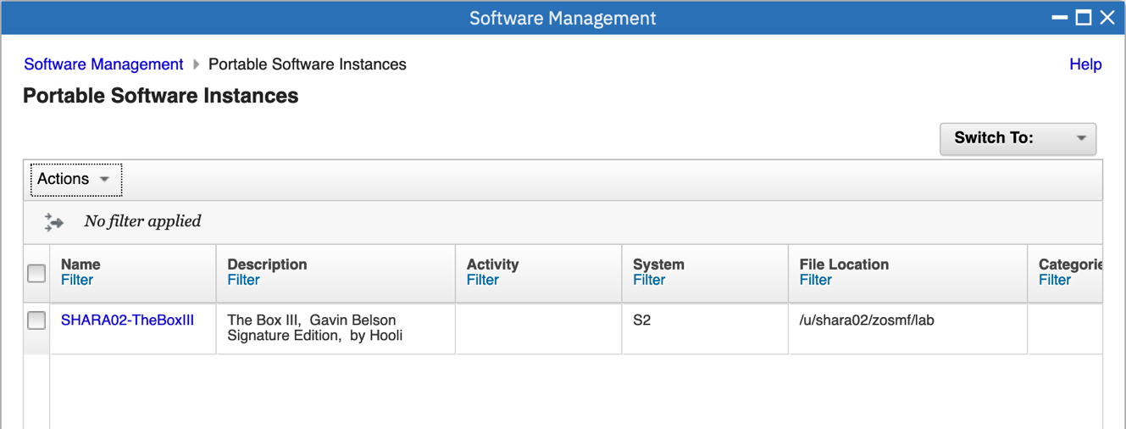

Let’s get the install (deployment) started. On the far right, click on the **Switch To:** drop down and select **Deployments.**

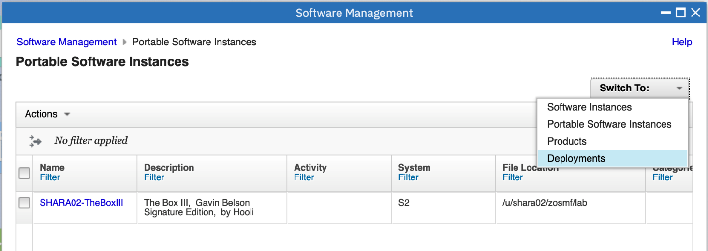

You are now in the Deployment section, and you are going to install (“deploy”) that portable software instance onto your system. This Deployment function is rather old in z/OSMF, so you might be familiar with it already. From the **Actions** drop-down, select **New.**

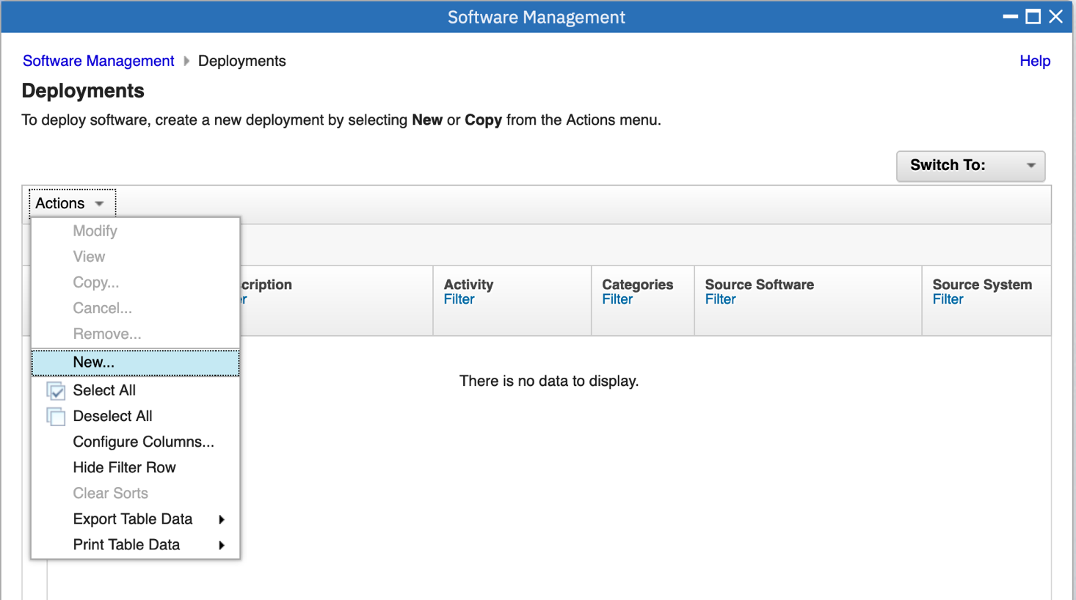

You have the mini-wizard for deploying (installing) the software instance. Select the first option, **Specify the properties for this deployment.**

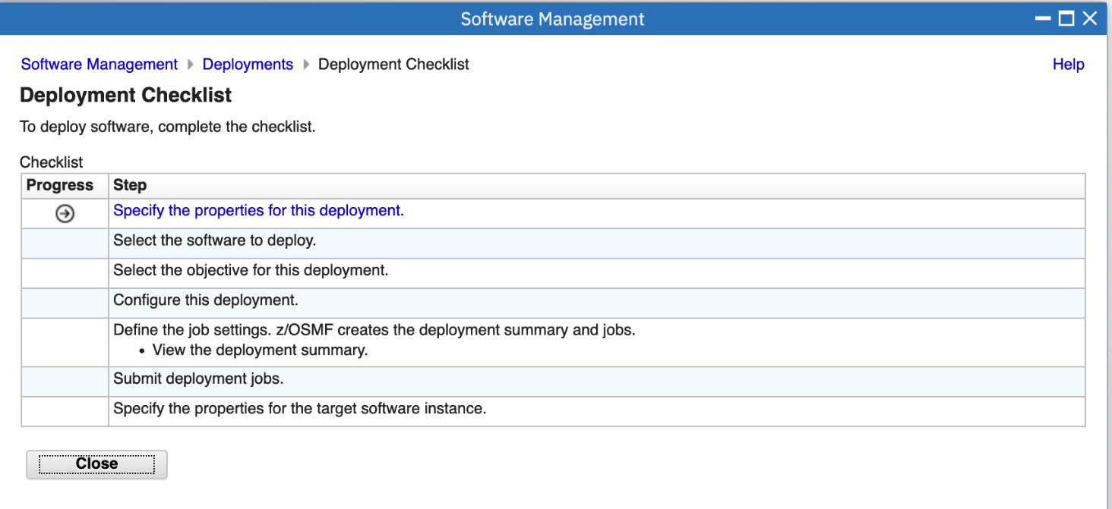

Fill in what you want to call the deployment. You have to pick a name that is unique since you can’t have duplication deployment names. Perhaps put your assigned userid in the deployment name to make it unique. Click **OK.**

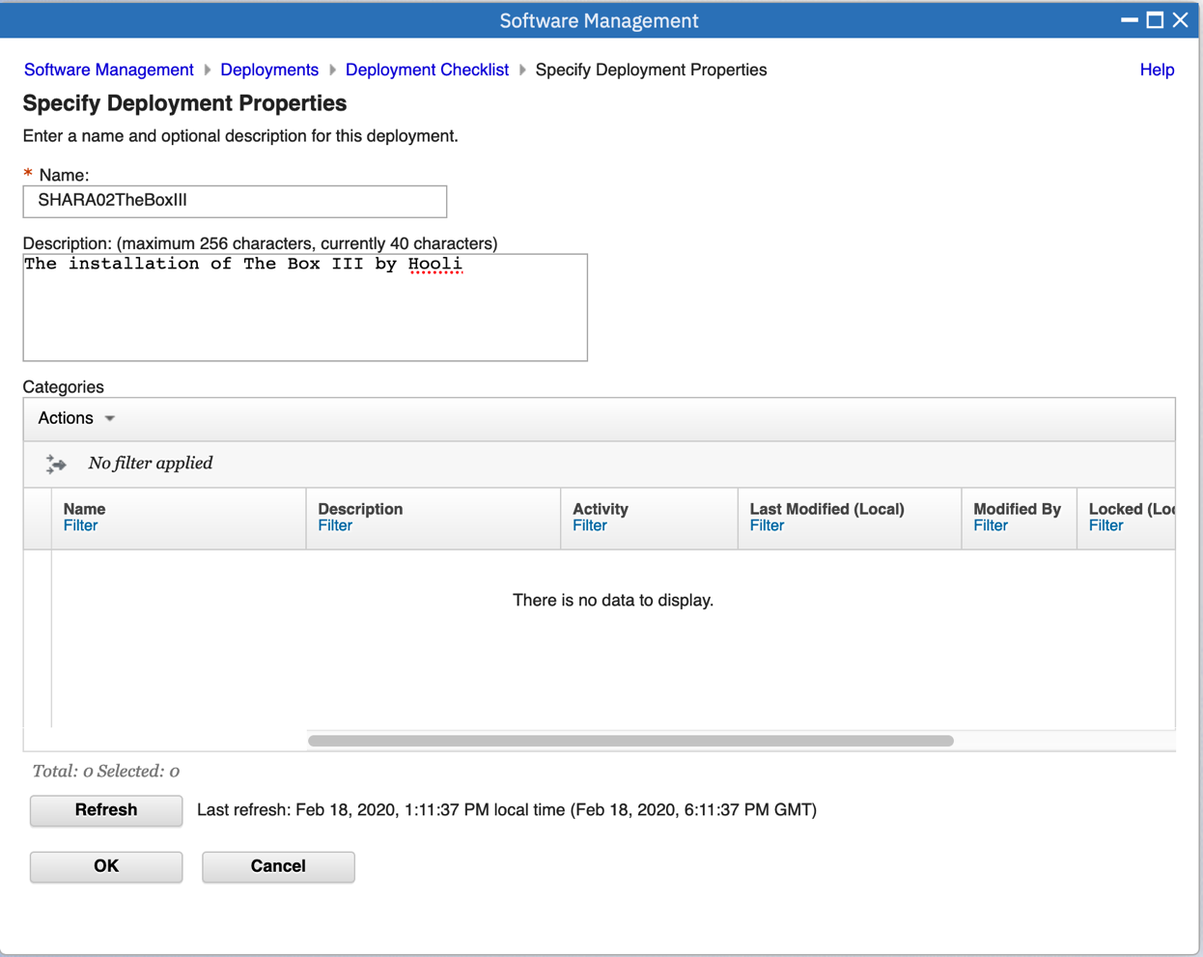

Then progressing through the mini-wizard, select the next step: **Select the software to deploy.**

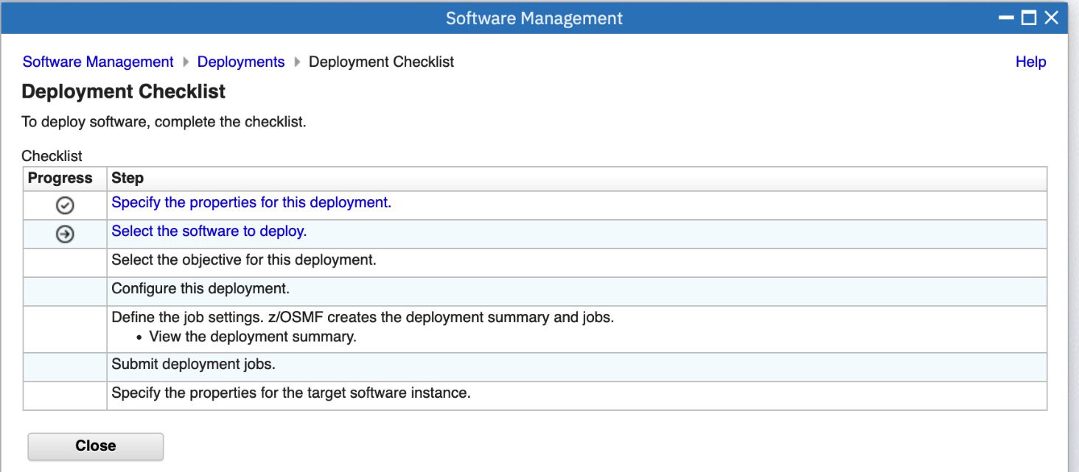

You want to select the **Portable Software Instance** you just received (the name you used when you added the Portable Software Instance above!). Then Select **OK** to continue. Then proceed with **Select the object for this deployment.**

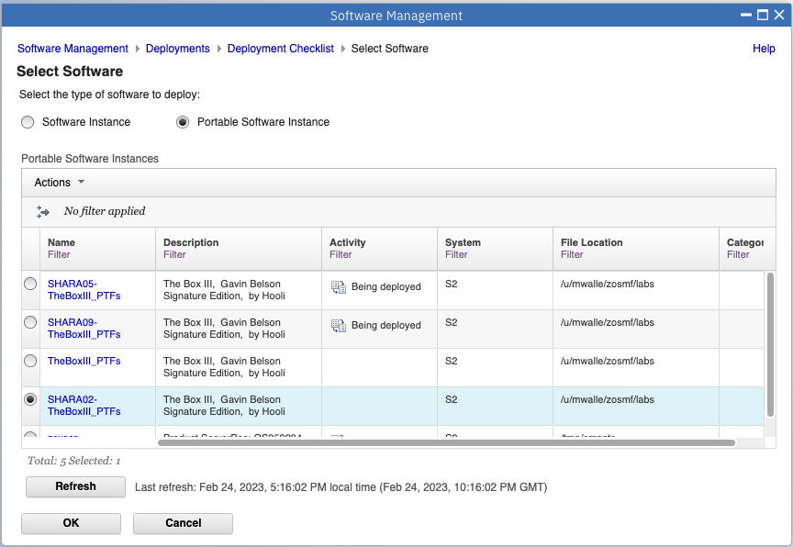

Then progressing through the mini-wizard, select the next step: **Select the objective for this deployment.**

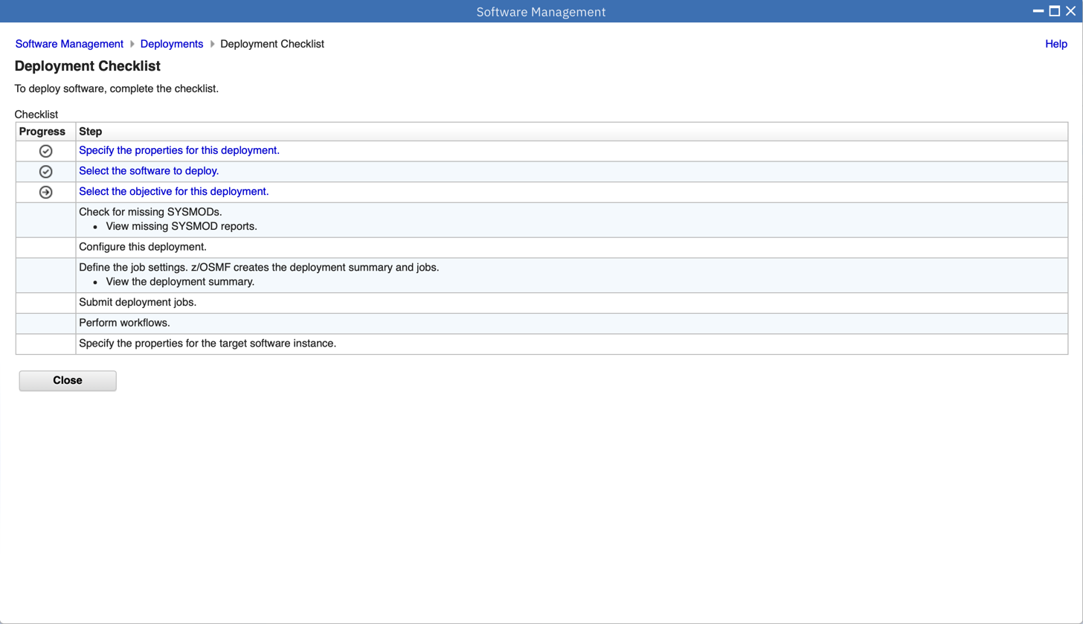

You are a customer, and you need to install this PSI. Select that you want to **Create a new software instance**, with **A new global zone CSI,** on your **S2** system.

This is not a z/OS order, so indicate that you are not deploying z/OS (where new master catalogs might be involved).

Then **OK.**

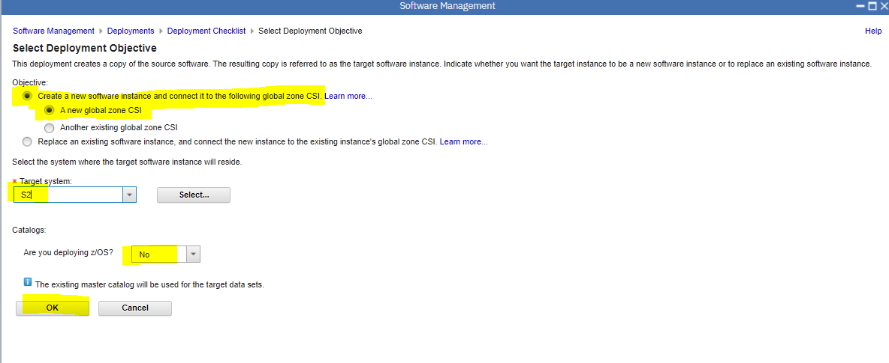

Continue on by clicking on **Check for missing SYSMODs** on the mini-wizard.

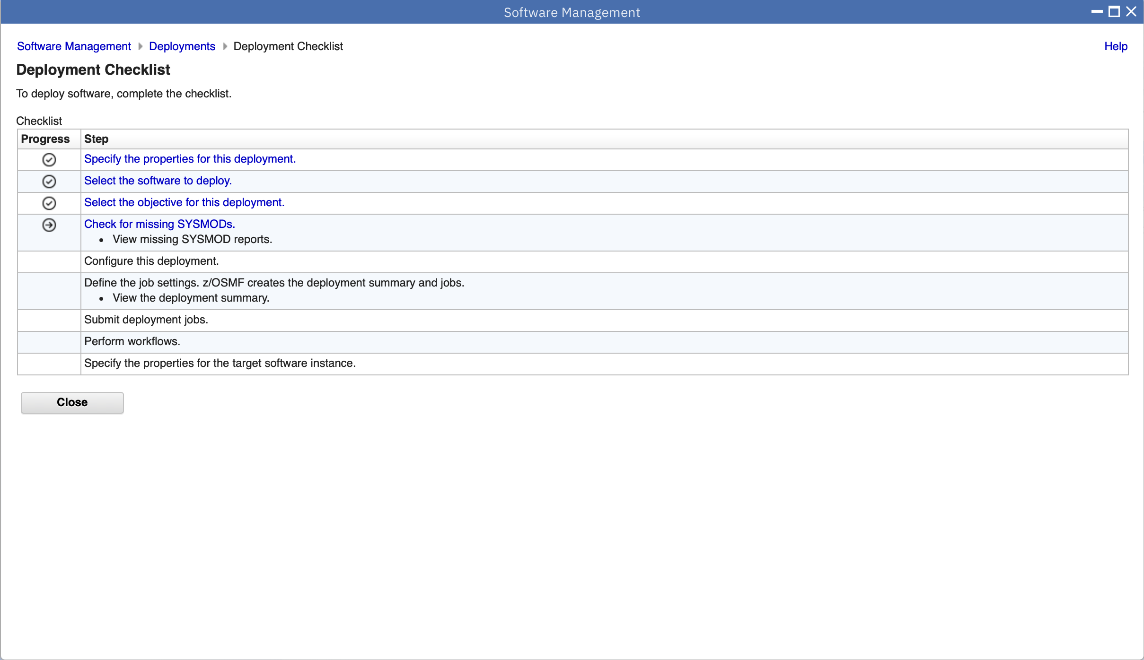

We are going to move through this older function very quickly, since it not unique for PSI installations. Do note, however, what you are doing at each step during the deployment. Click on **Next.**

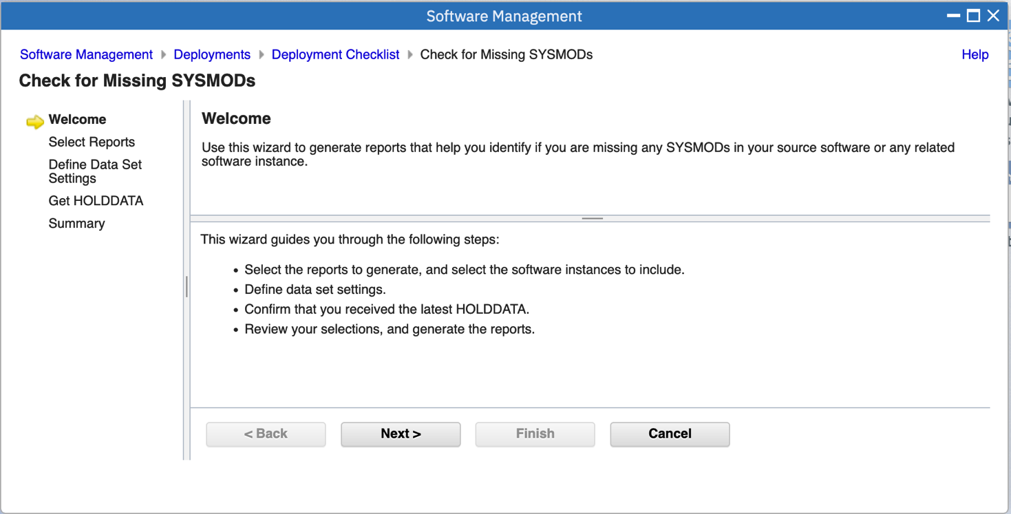

This is where you can run various SMP/E reports to see if any dependencies are missing or regressions would happen between this software instance and other software instances you already have. We are going to skip this portion, so uncheck the two boxes, and click on **Finish.**

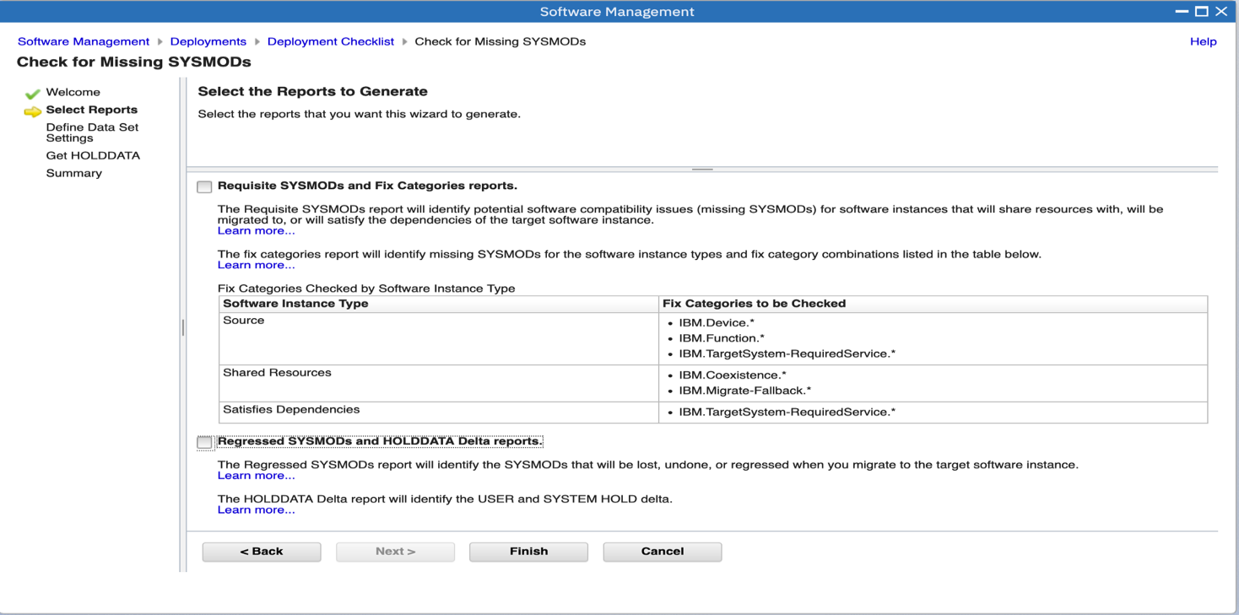

We understand that it is not recommended to skip the dependency and regression reports, so click **OK.**

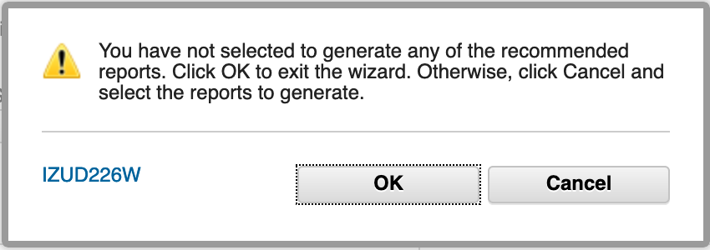

Then back on the mini-wizard, select the next step: **Configure this deployment.**

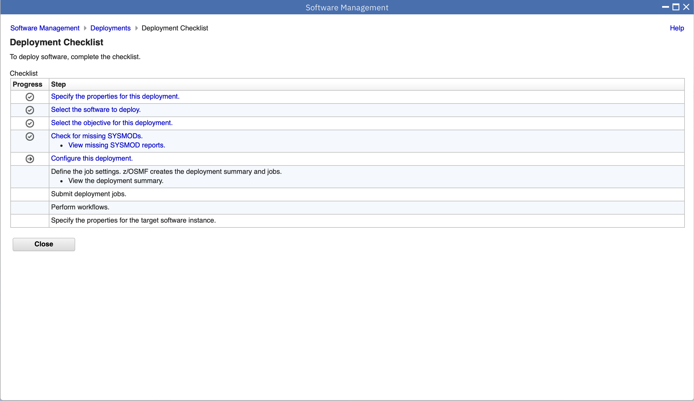

This is where you can do a lot of customization for how you want this PSI installed! After reading through all the items that we are going to (briefly) go through, click **Next>.**

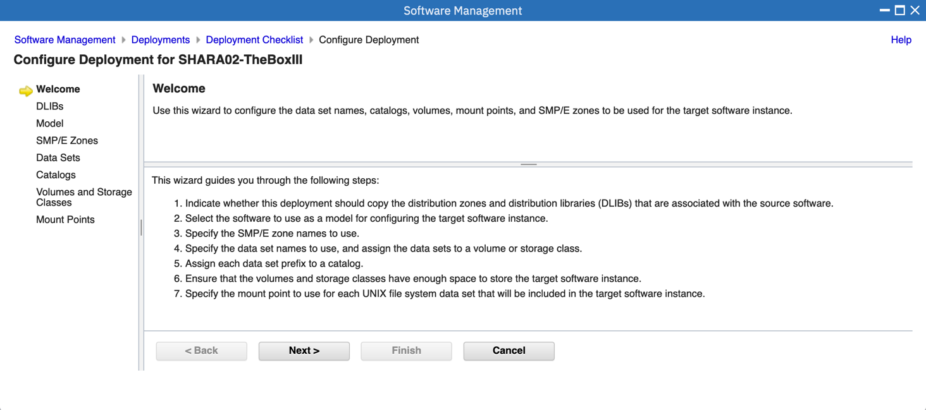

Select **Yes** because we want to take the DLIBs associated with the source software. Then **Next>.**

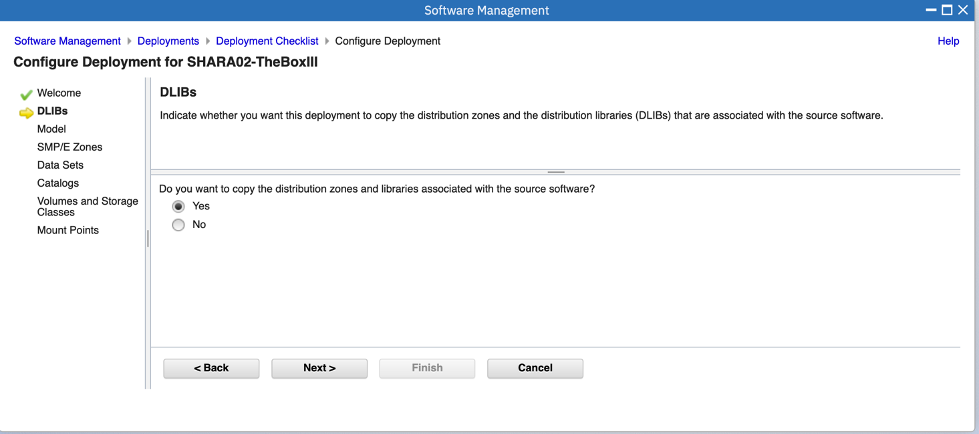

Assuming that this is the first time we’ve ever installed this product, we are going to model this deployment on what was sent to us.

*Let’s pause here a bit:* when you are installing a product you already have (like the z/OS V2.5 operating system), it really is best to model after a prior level of z/OS (like V2.3 or V2.4). This is where you would do that. This saves a lot of time, as the data set placement and names you have in place for the older z/OS release, can be brought forward to the newer z/OS release.

For this lab, though, just select **The source software**, then click **Next>**.

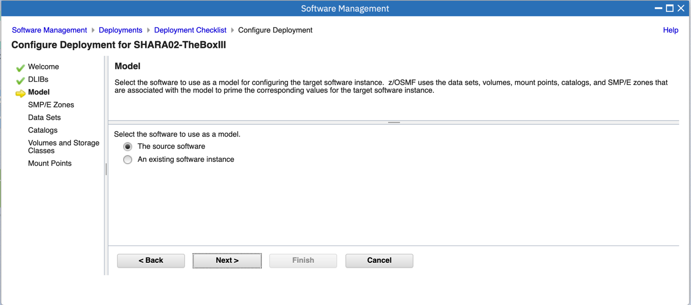

Wait just a bit:

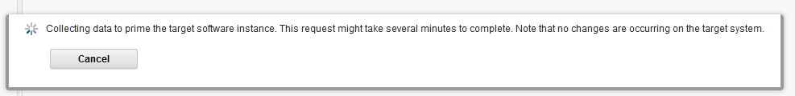

To show how easy it is to decide your own target and dlib zones names, enter something new here. Then click **Next>.**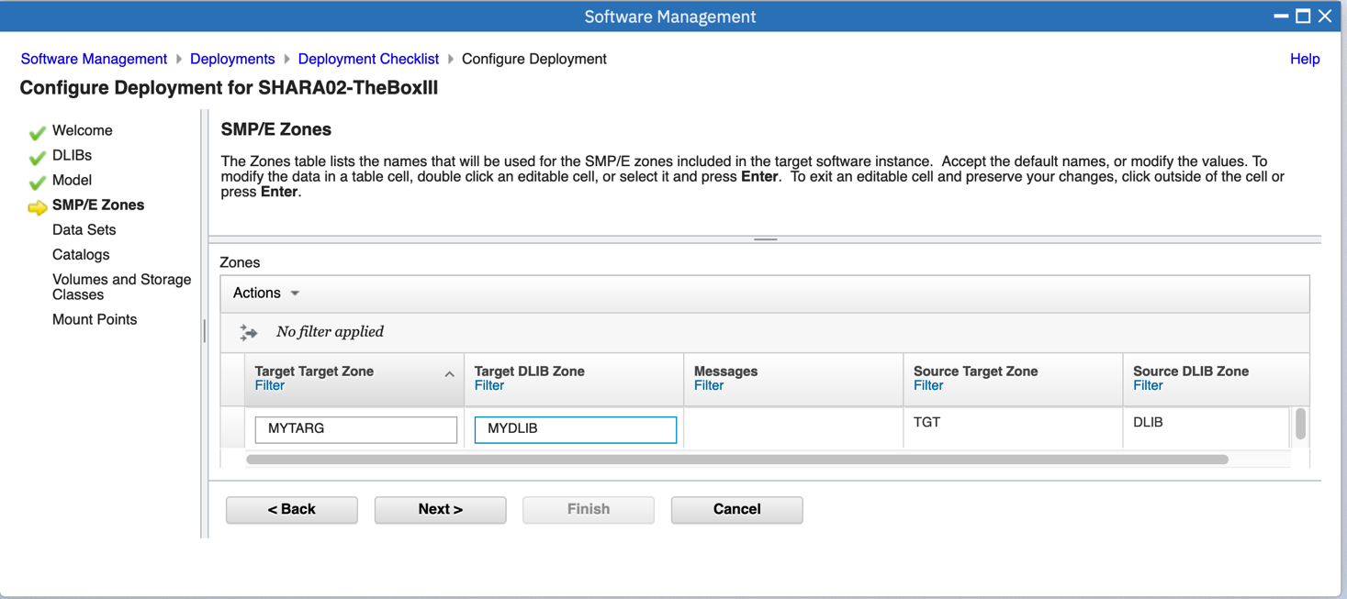

This is where you could spend a lot of time customizing the names and placements of data sets in your environment. Notice something interesting here: this PSI contains both SMP/E and non-SMP/E data sets, proving that the PSI doesn’t care what it contains, and can handle both SMP/E and non-SMP/E data sets just fine. Of course, it doesn’t even need to contain any SMP/E installed products if the ISV didn’t want to package their product with SMP/E.

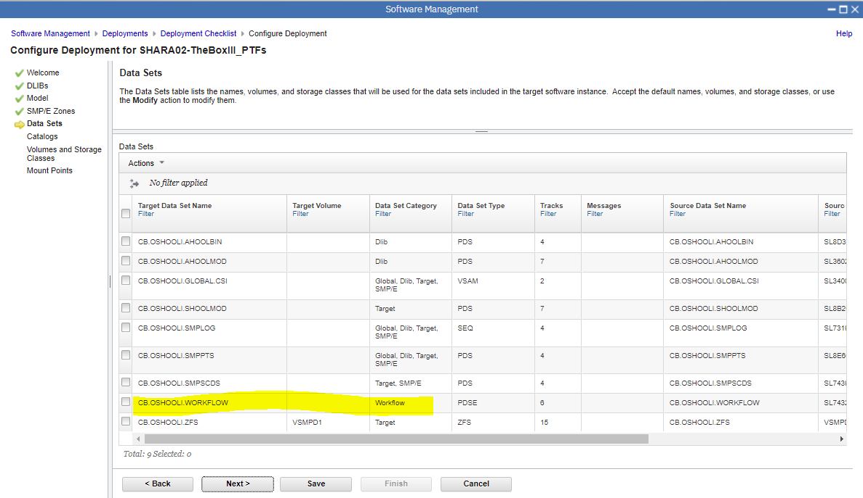

You will need to change the Target Volume for all the datasets listed. Click on the upper left checkbox to select all the data sets, then Click **Action -> Modify**.

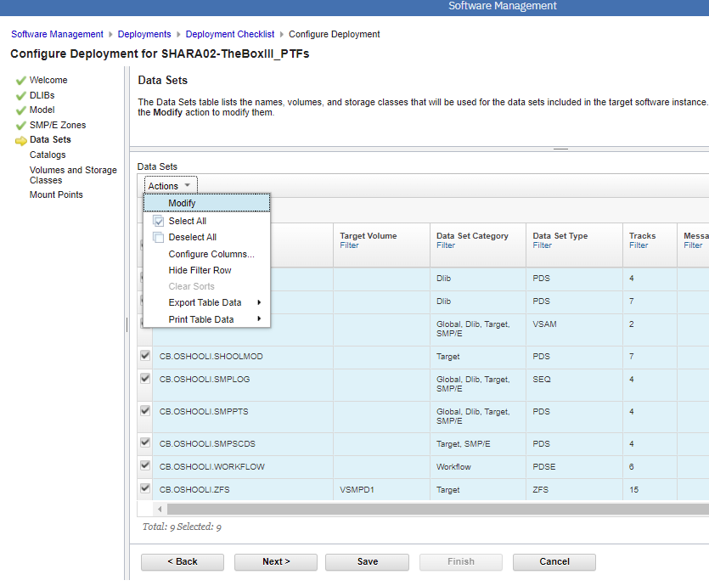

You can change the HLQ (and volume) of all these data sets very quickly.

Change the **To:** from **CB.OSHOOLI** to **<your_userid>**.**HOOLI** You might need to change to a different HLQ, if someone else had done this lab before, and has selected the same HLQ as you. Just pick something with your userid in it, and “HOOL” so we know what we can clean up on the system.

Select **Storage class** and enter **TSOPOOL** for the type, then click **OK**.

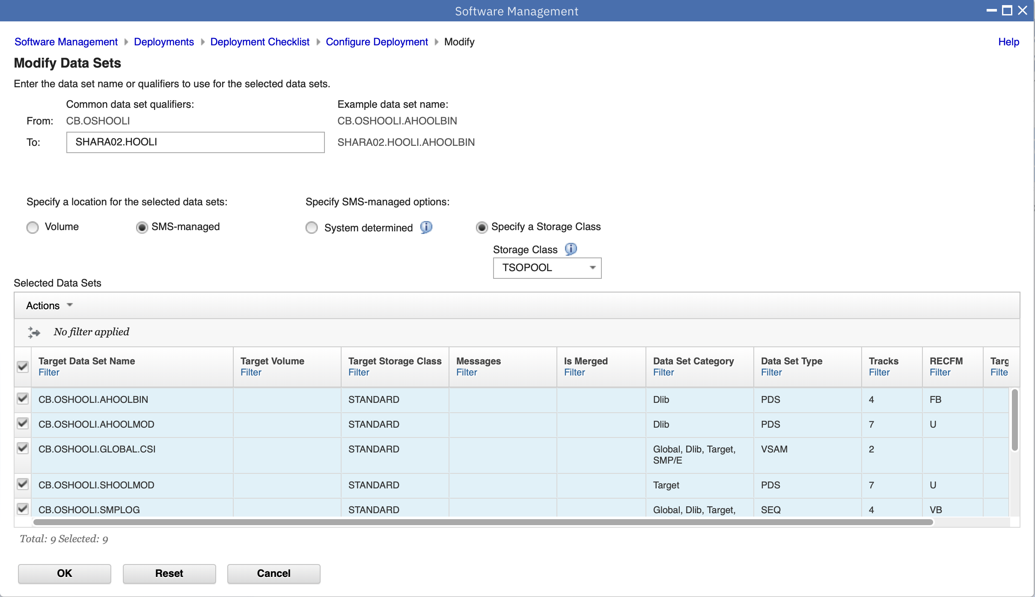



If you wanted to investigate more functions like renaming or moving data sets, select the data set(s) and then do **Actions->Modify.** To move through this lab quickly, though, we won’t show that. It is pretty intuitive once you select the data set. Spend time on this option if you like. Click on **Next>** when you are done.

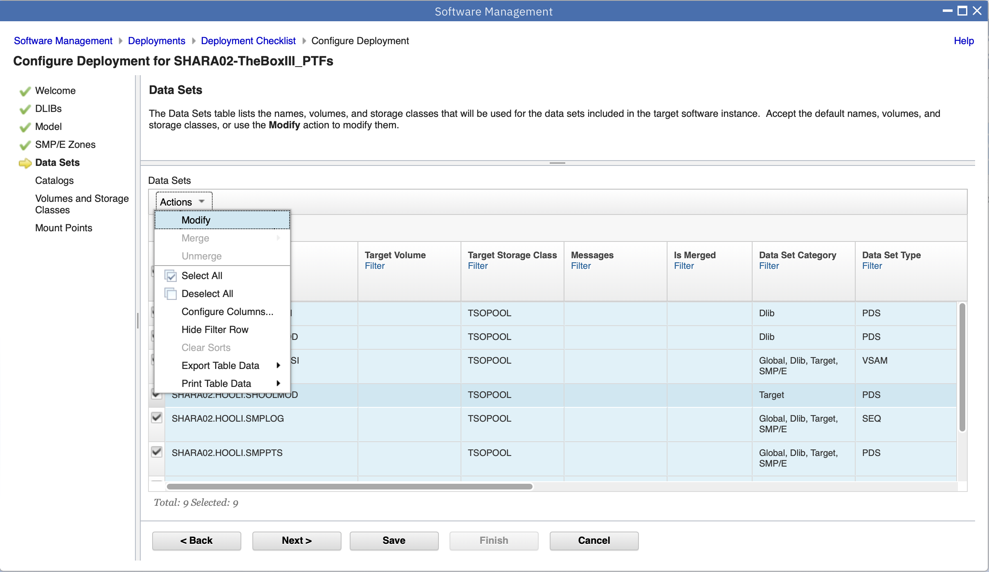

Here is where you would ensure the cataloging is as desired. If you want to investigate, just select your Prefix, and then **Actions ->** and what you’d like to do.

Click **Next >** to continue.

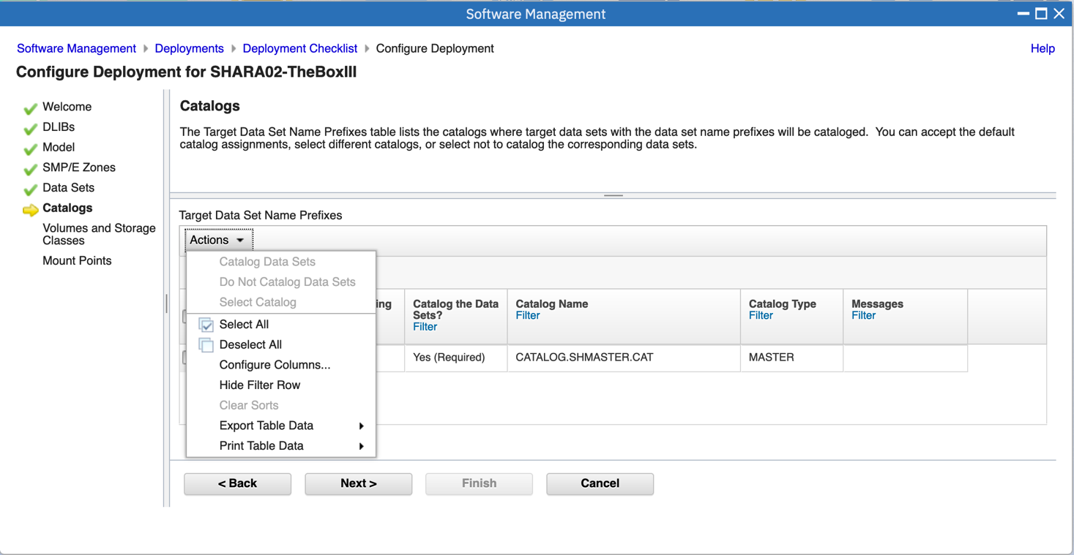

Next up is Volumes and Storage Classes. Since we updated this in the **Data Sets** step, this product will use Storage Classes. You could change volumes or Storage Classes here if you wanted. Keep going. Click **Next>.**

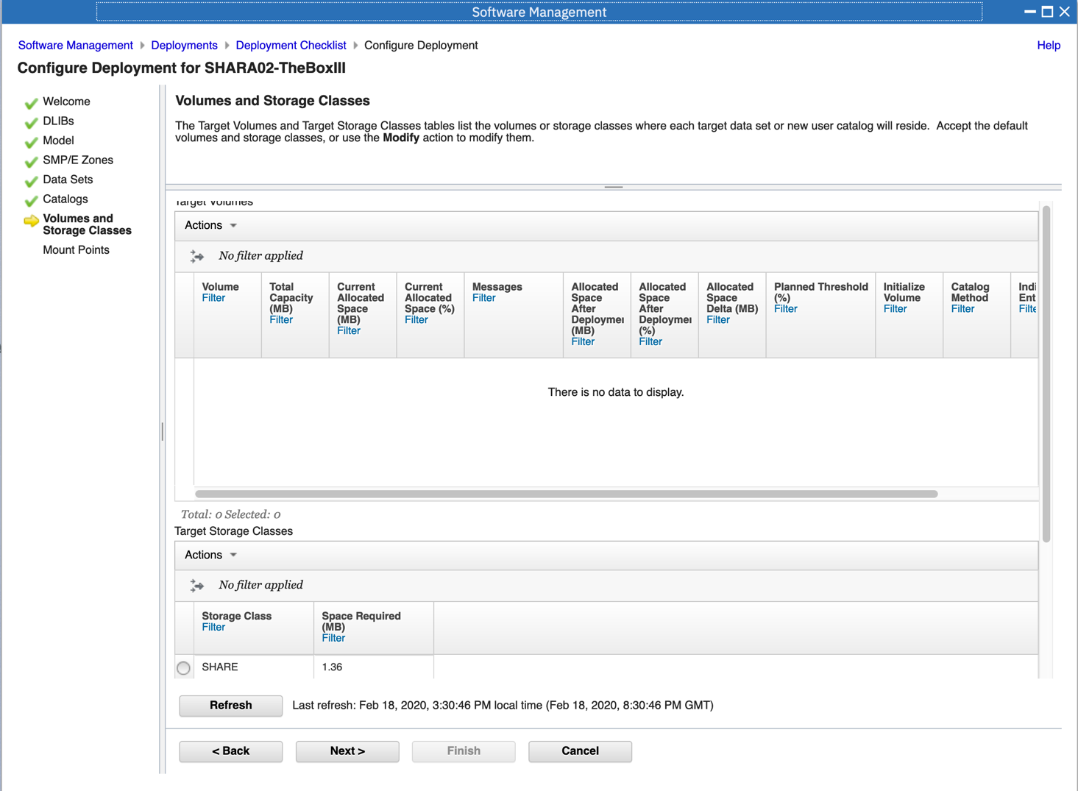

We are now at the last configurable change to do for the deployment: **Mount Points**. Select the mount point listed, click **Actions -> Modify Target Mount** Point.

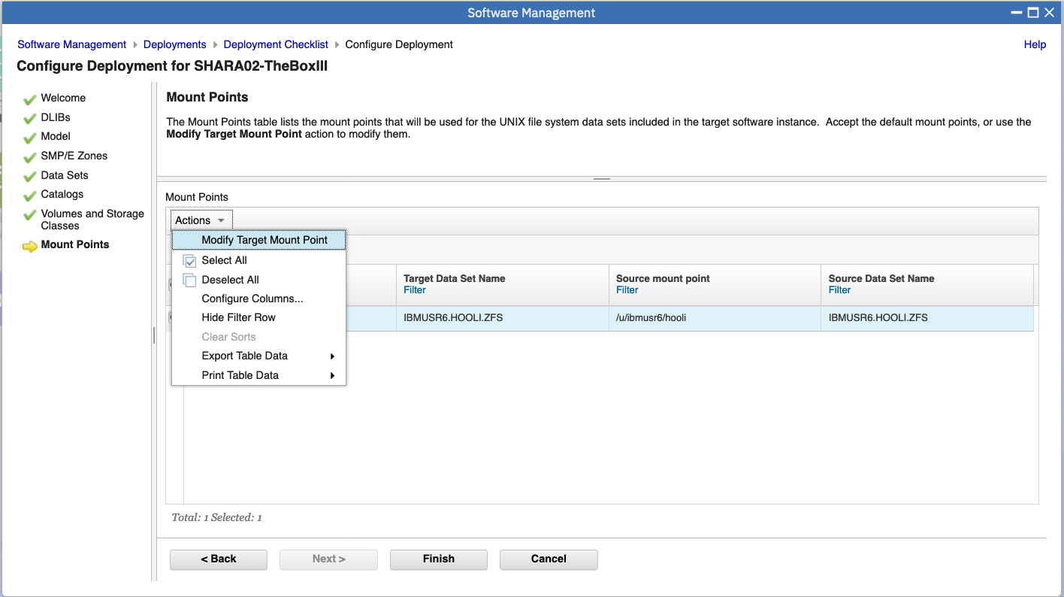

Change the To: to /u/**<yourid>**/hooli, and click **OK**.

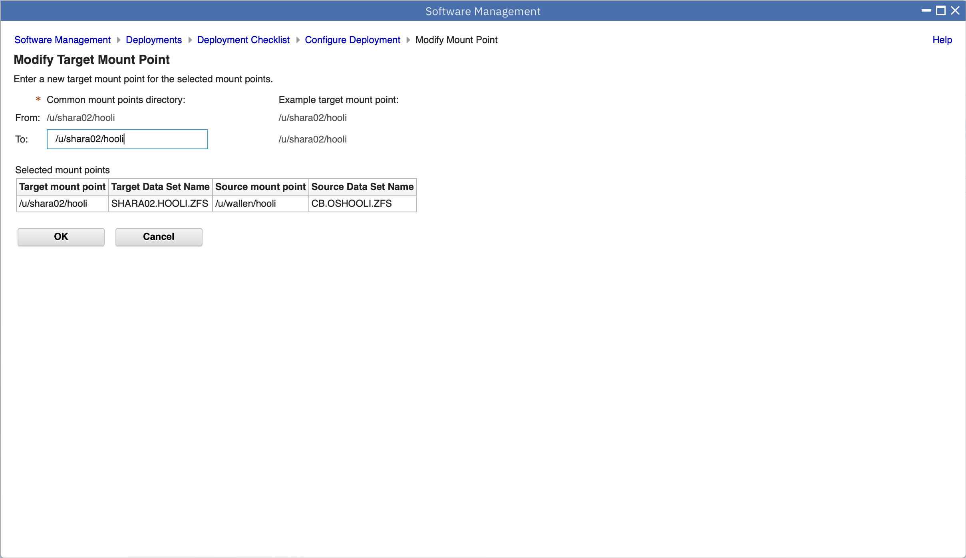

Then on the next screen click **Finish**.

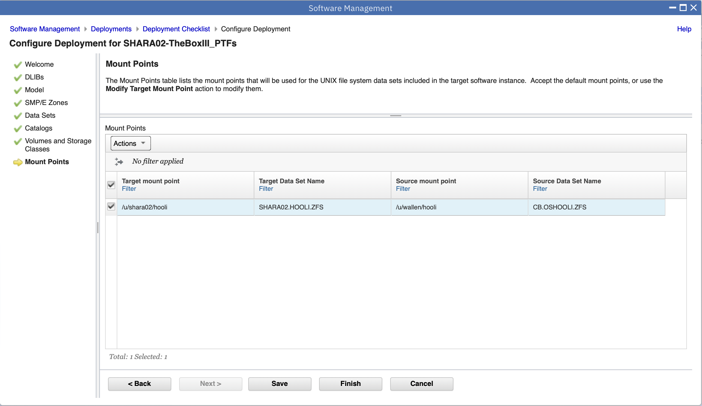

Back on the Deployment Checklist, we are moving right along. Click on **Define the job settings. z/OSMF creates the deployment summary and jobs.**

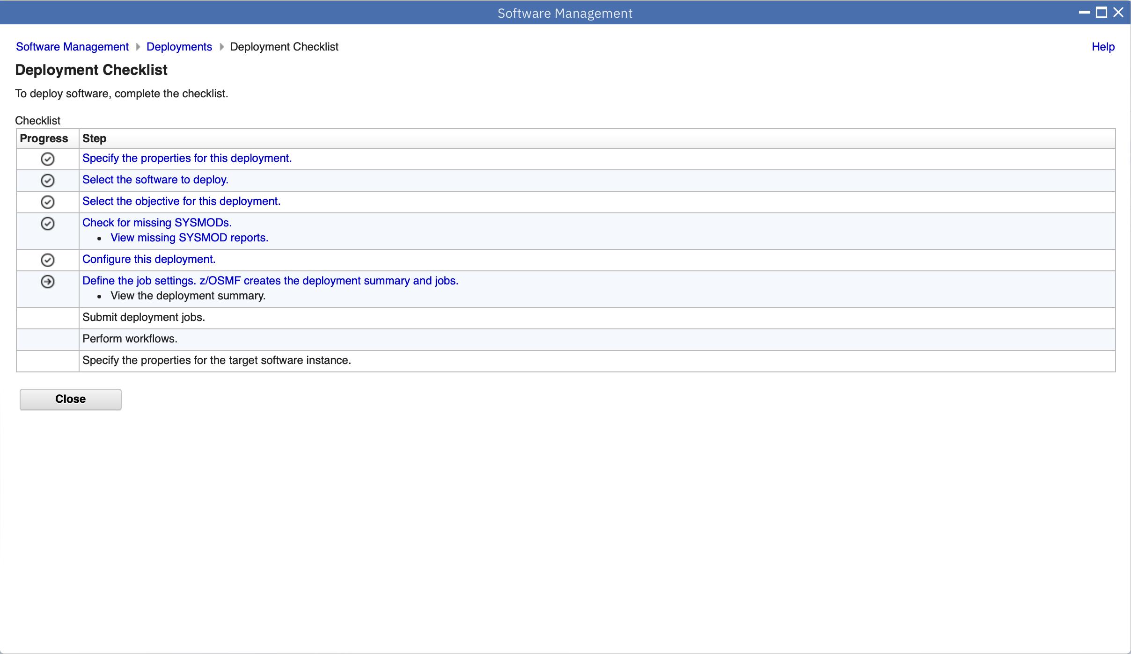

The deployment process we just went through will create a series of jobs to run. You can indicate where you want the jobs stored, and the JOB statement to use. You will also need some temporary space and you can indicate that here. Use “**System determined”** to show that we’ll just let the DFSMSsms ACS routines handle where to put this temporary space

For now, update the **JOBNAME** and ensure you have REGION**=0M** then click on **OK.**

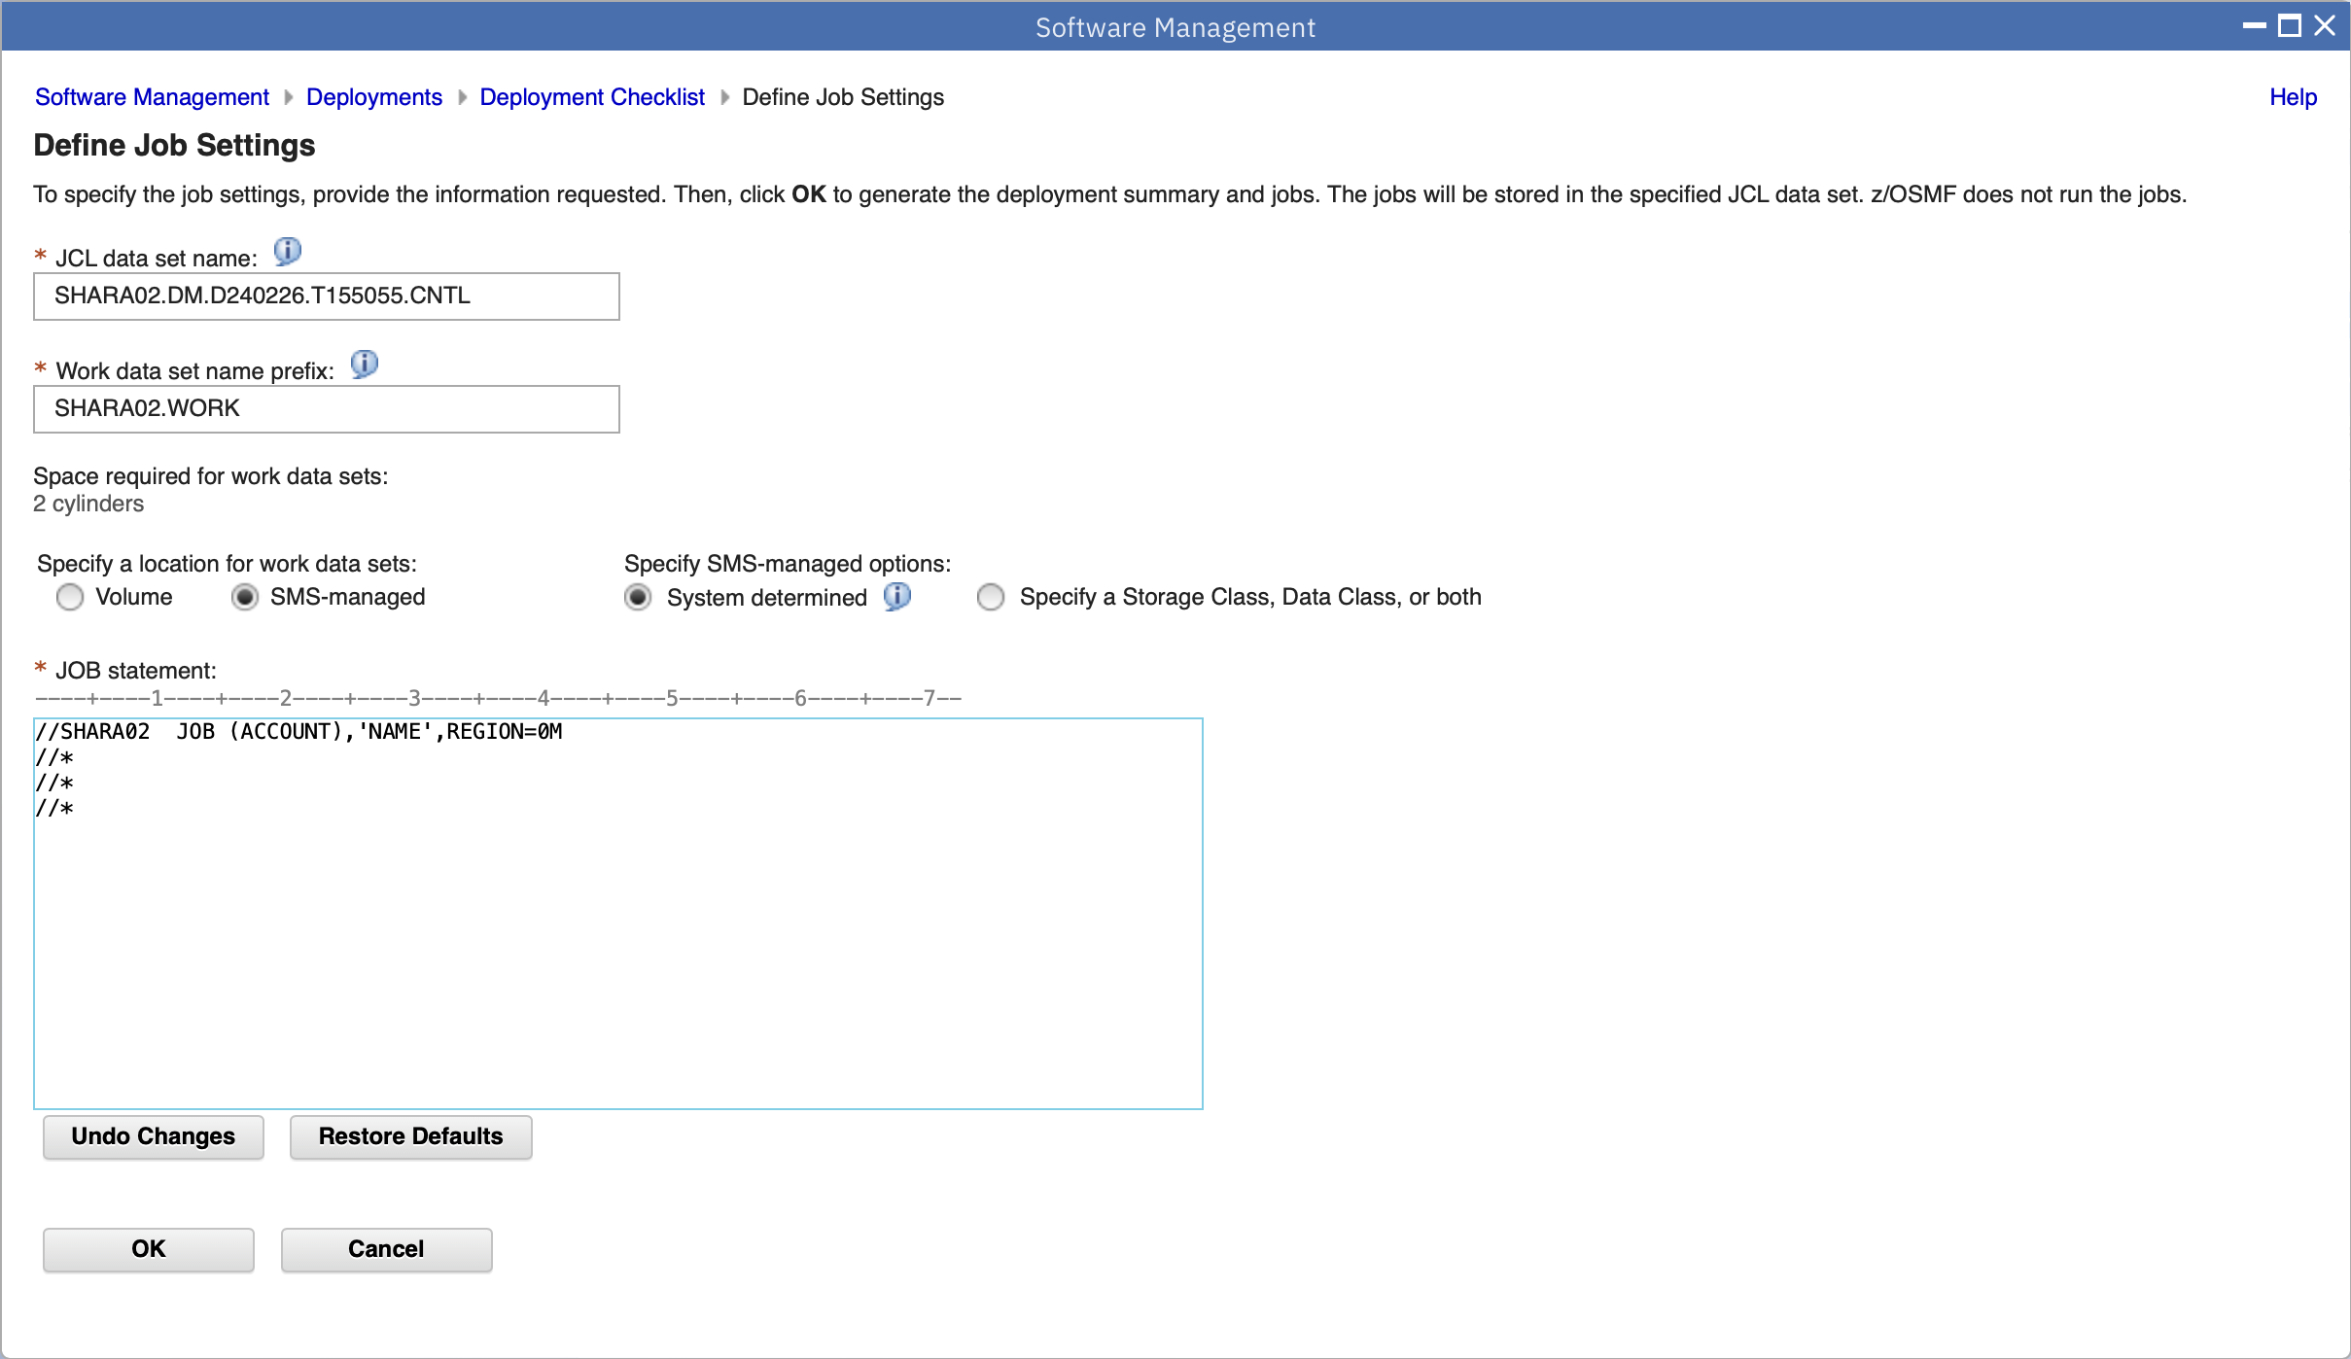



Jobs are created:

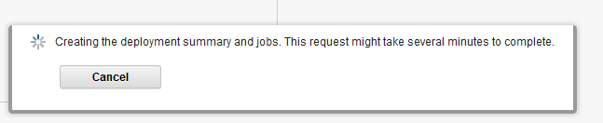

Back on the Deployment Checklist, click on **Submit deployment jobs**.

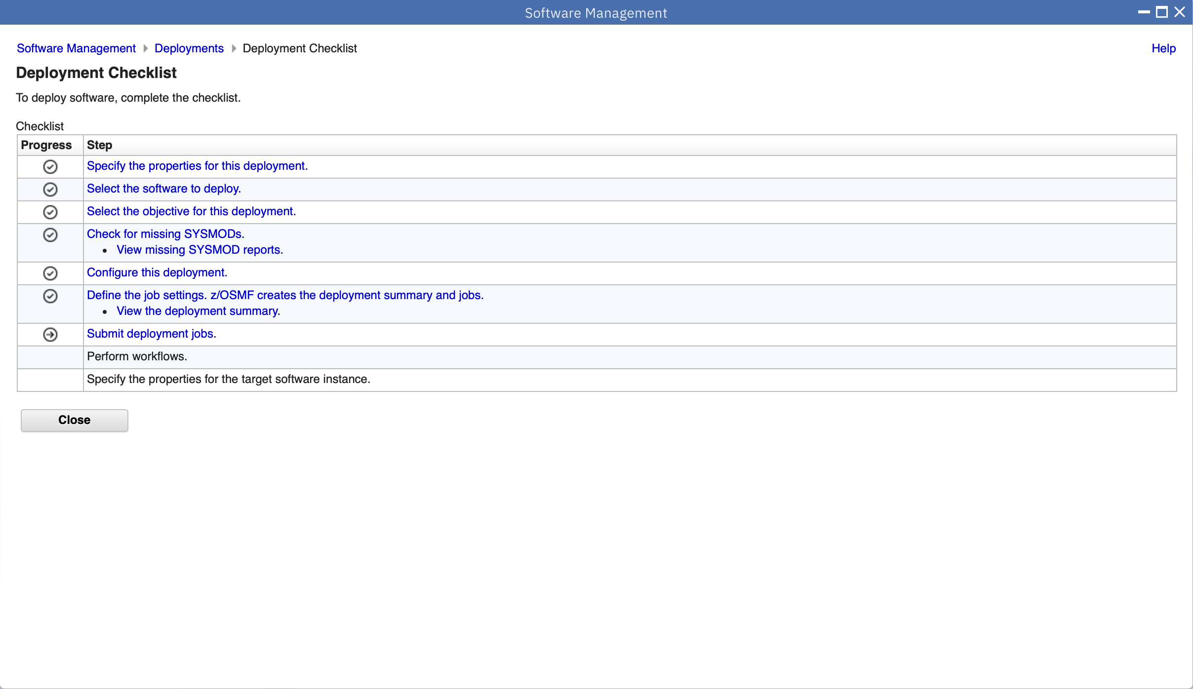

In the deployment window, select the first job, and click **Actions -> Submit Job**. You can read the description of what each of the jobs will do.

Click Refresh, eventually the Status will move to complete.

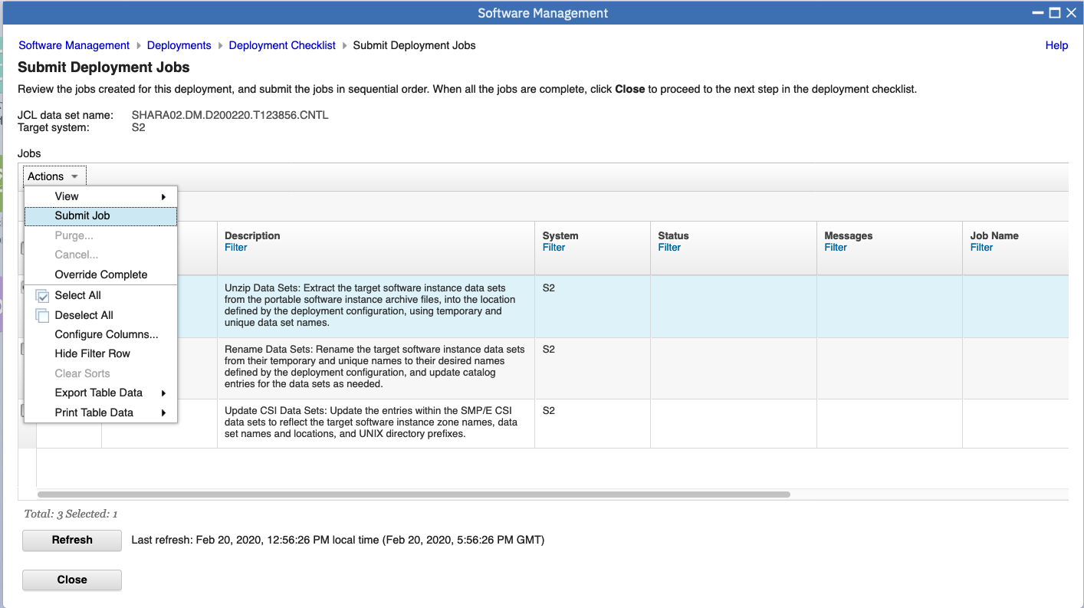

To see the Job output, select the job, click **Actions -> View -> Job Output**.

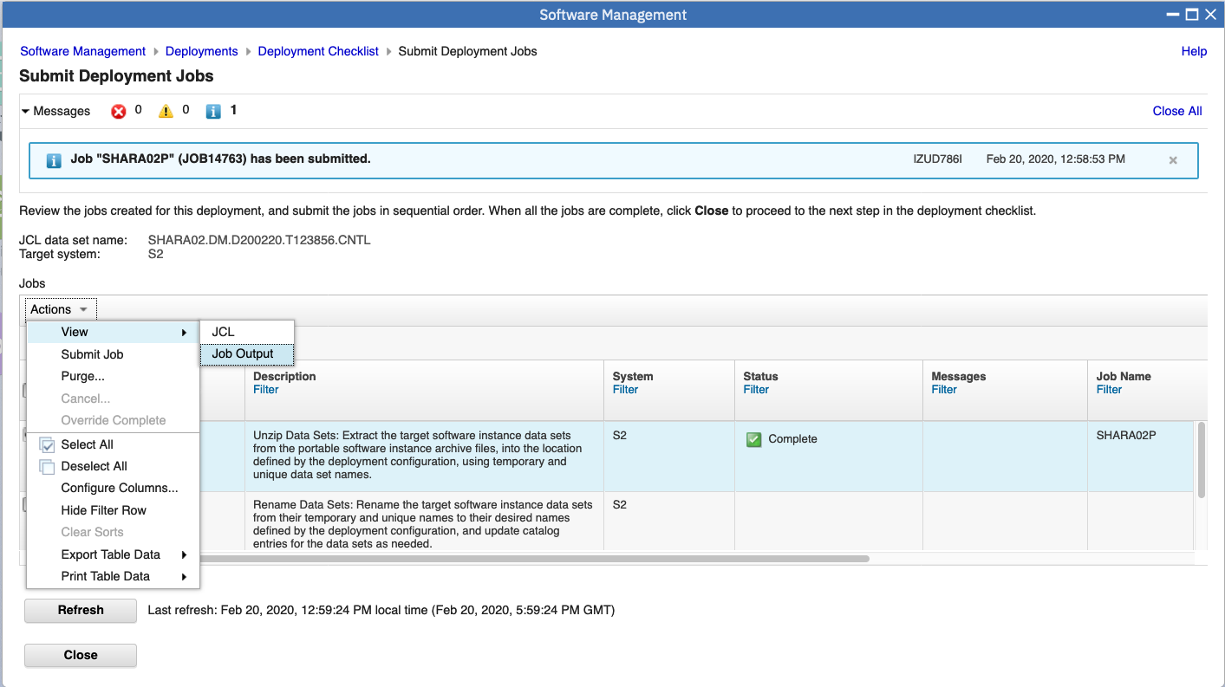

When you’re done you can click **Close.**

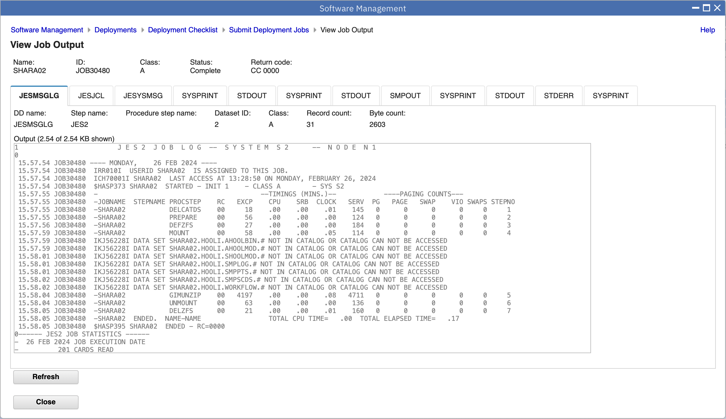

Go ahead and submit the other 2 Jobs. Click **Close** when you have completed all three jobs.

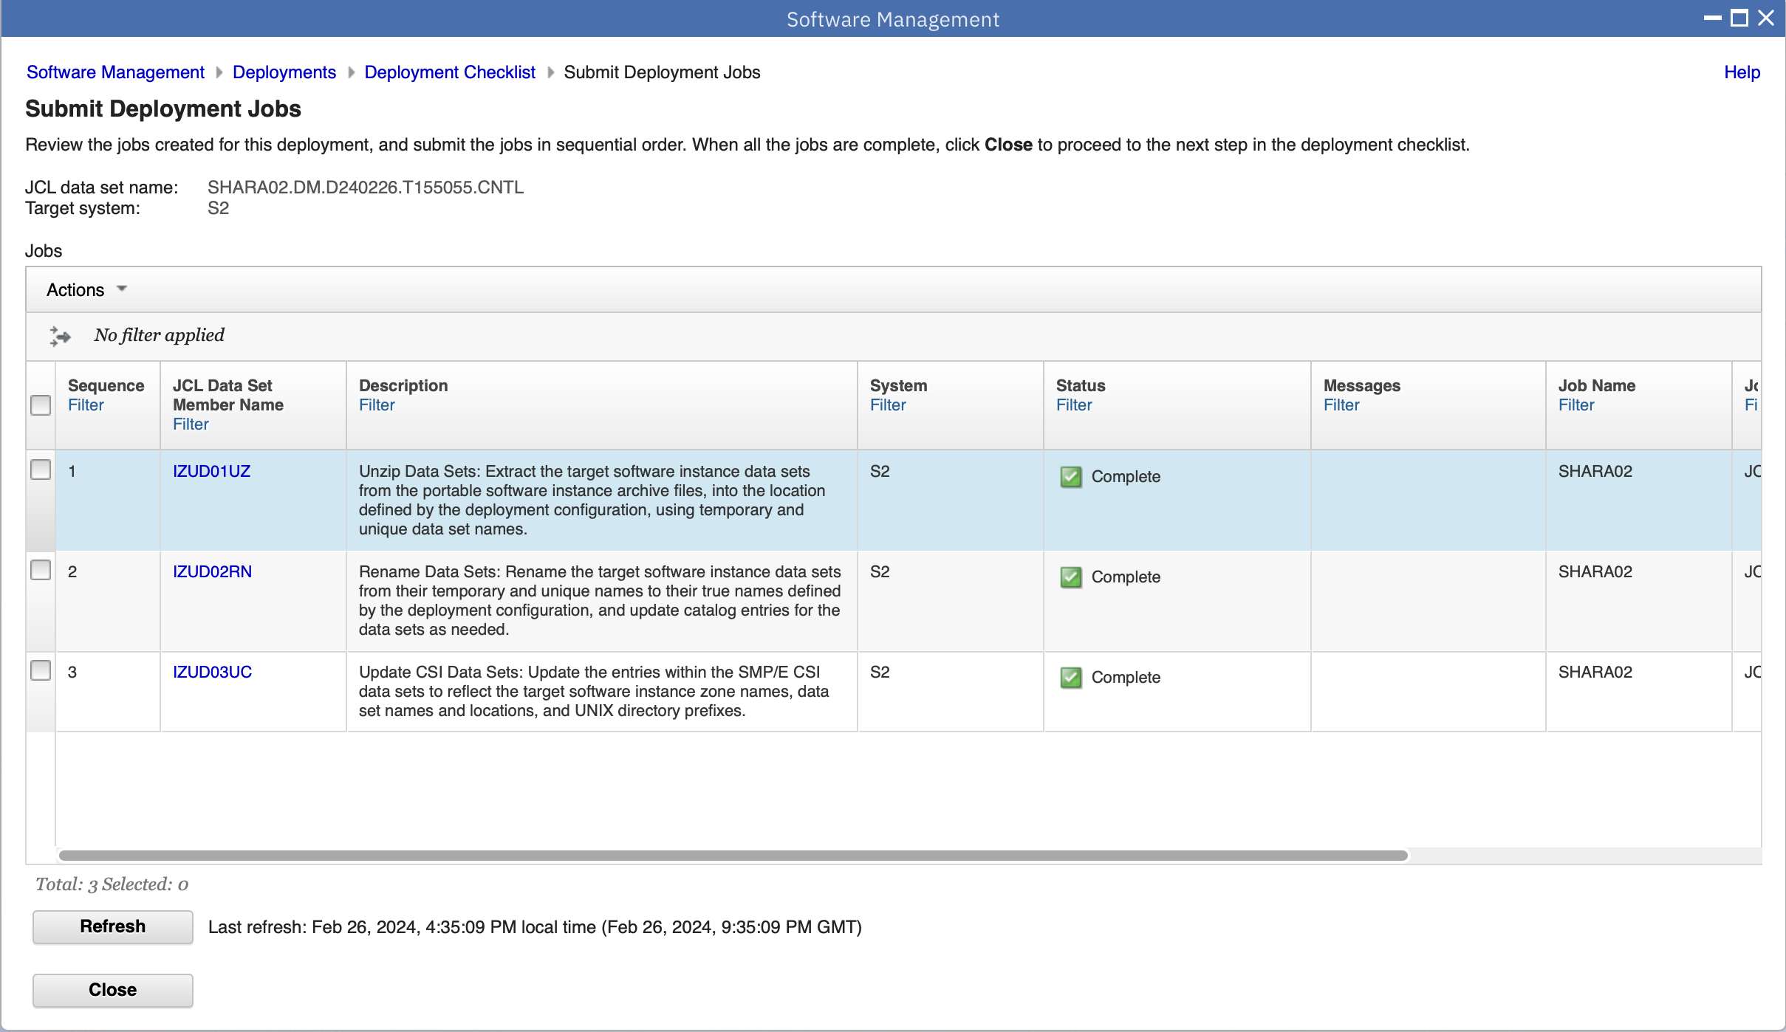

Back on the Deployment Checklist, click on **Perform workflows**.

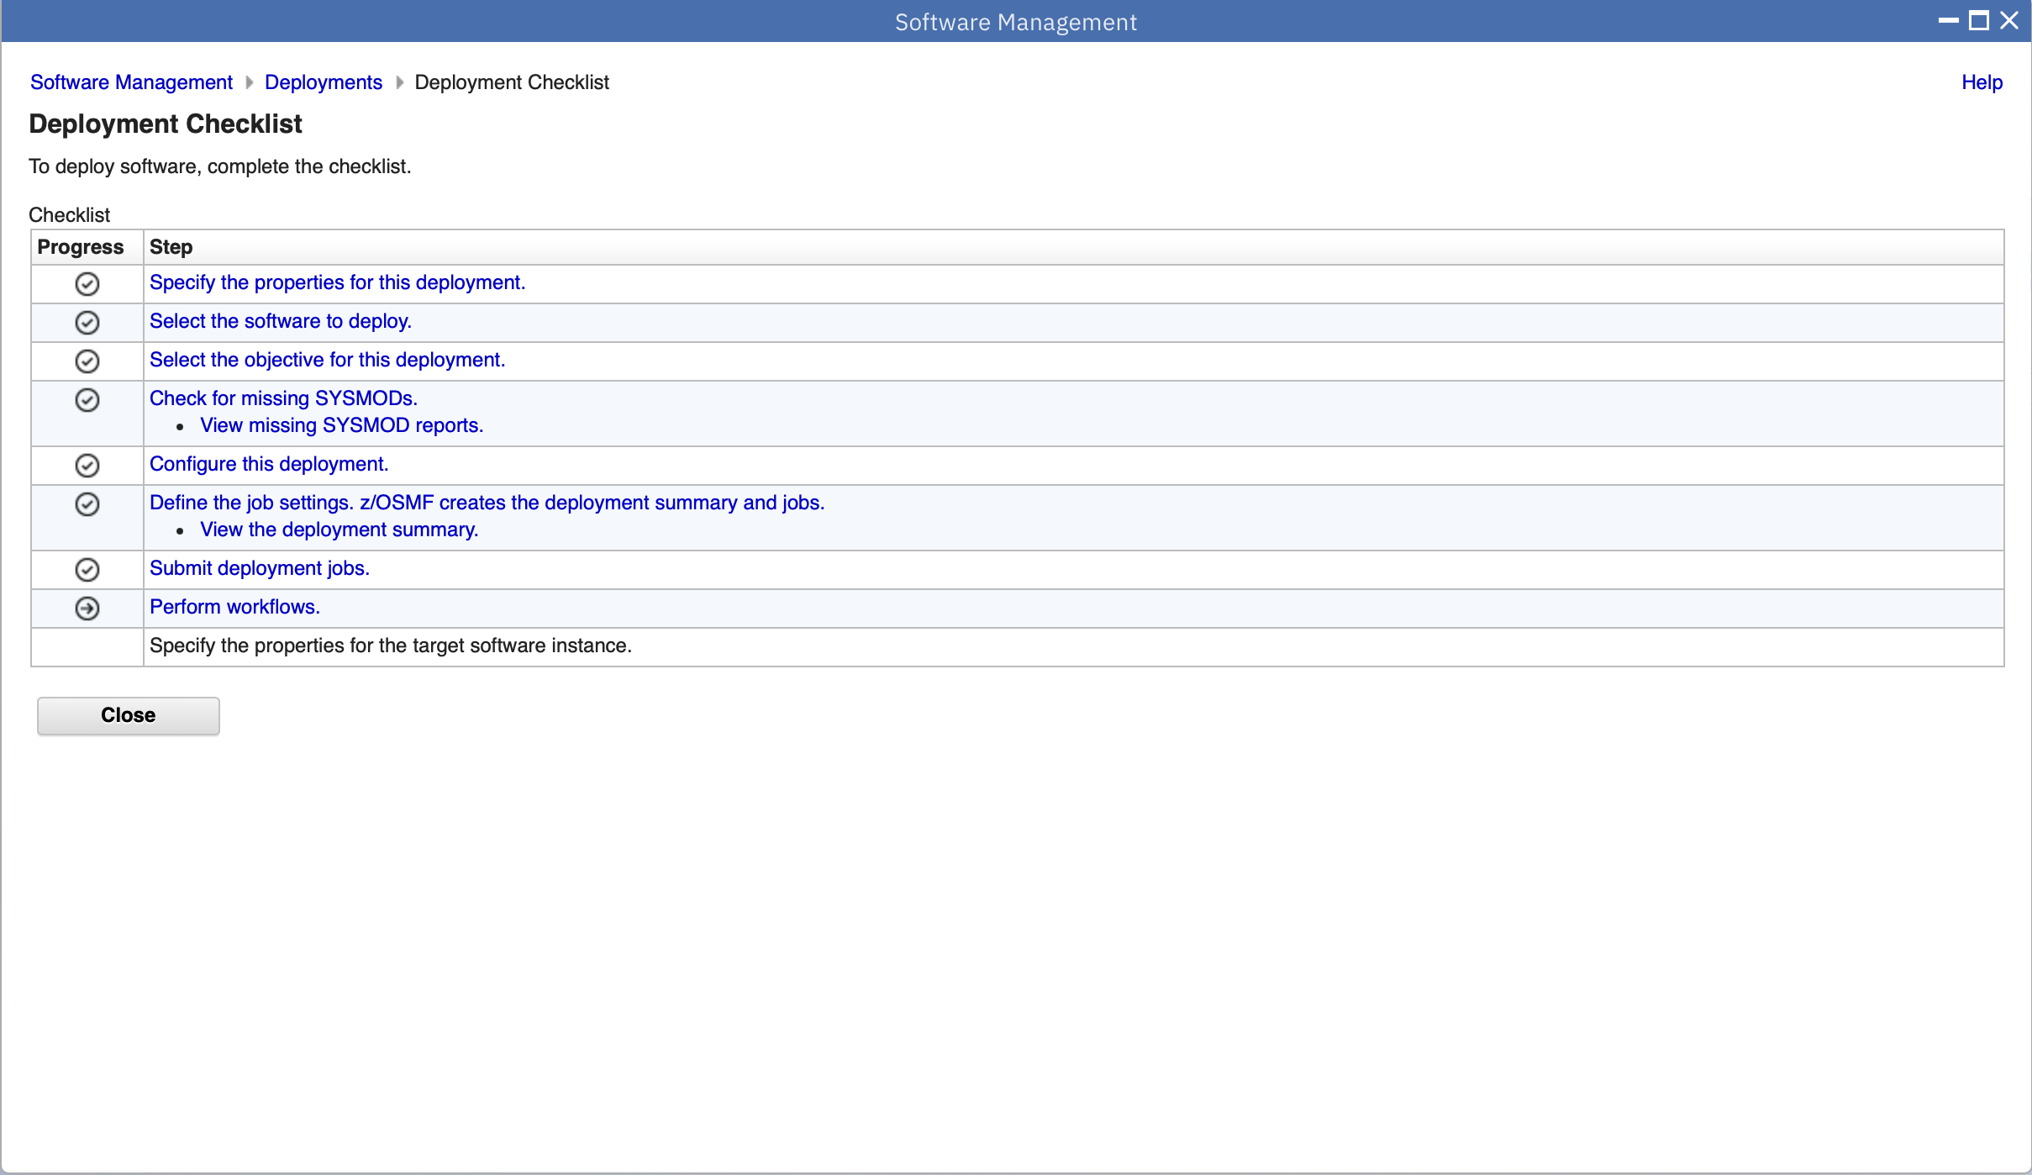

In the Perform Workflow window, you will see there are 3 workflows. Select the first workflow, About your order, and click **Actions -> Open**

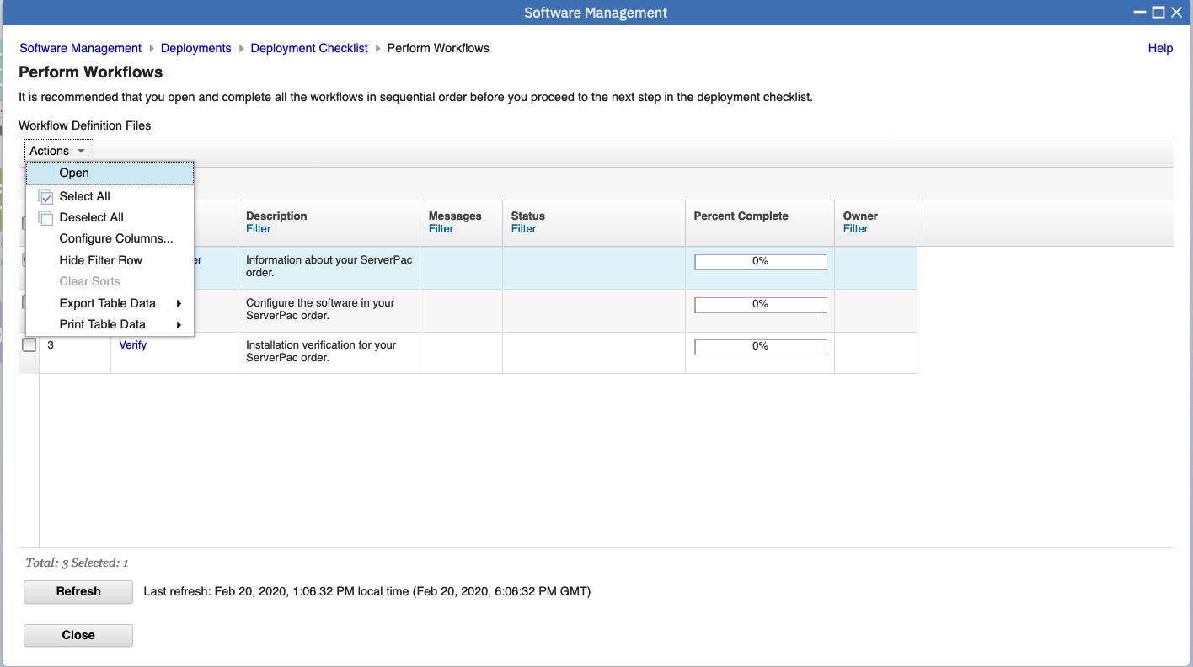

This action will create the workflow “About your order”. Once created, it will bring you into that workflow, in another window.

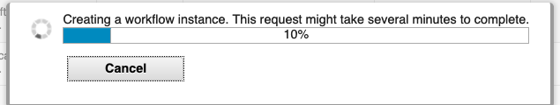

In the Workflow, **About your order**, You will see two steps, **Copyright** (a Leaf Step) and **About Your Order** (A Parent Step), and if you click on the **+** next to **About Your Order**, you will see several additional leaf steps.

To perform the step, select the step, then click on the title, (example click on **Copyright**)

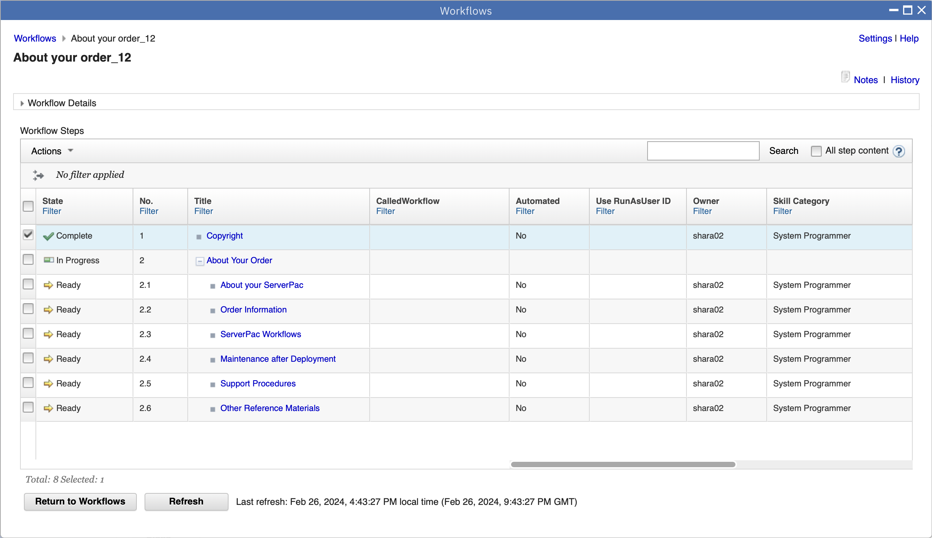

The **Copyright** is informational only, go ahead and click on the different tabs. When you get to **Perform**, click on **Finish**. 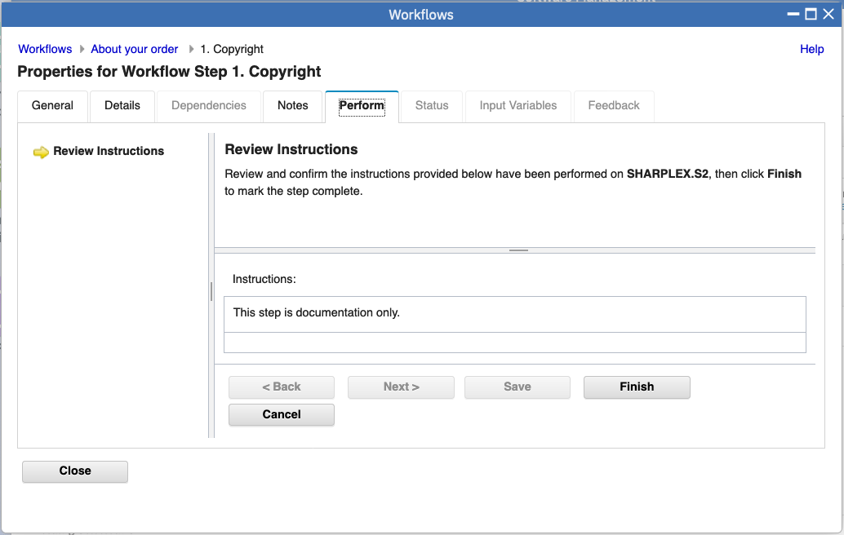

The rest of the steps in this workflow are also informational. Complete each step until all the steps are complete.

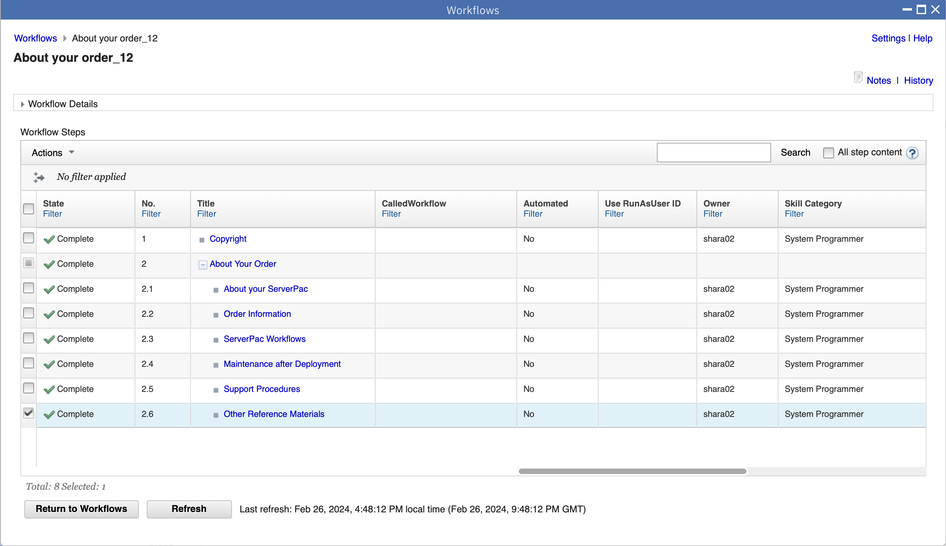

You can click on **Return to Workflows** when you are ready to go back to your deployment tasks in z/OSMF Software Management from Workflows.

Go back to **Software Management** window, **Perform Workflow** and click **Refresh**, you will see that the About your order step will be marked Complete.

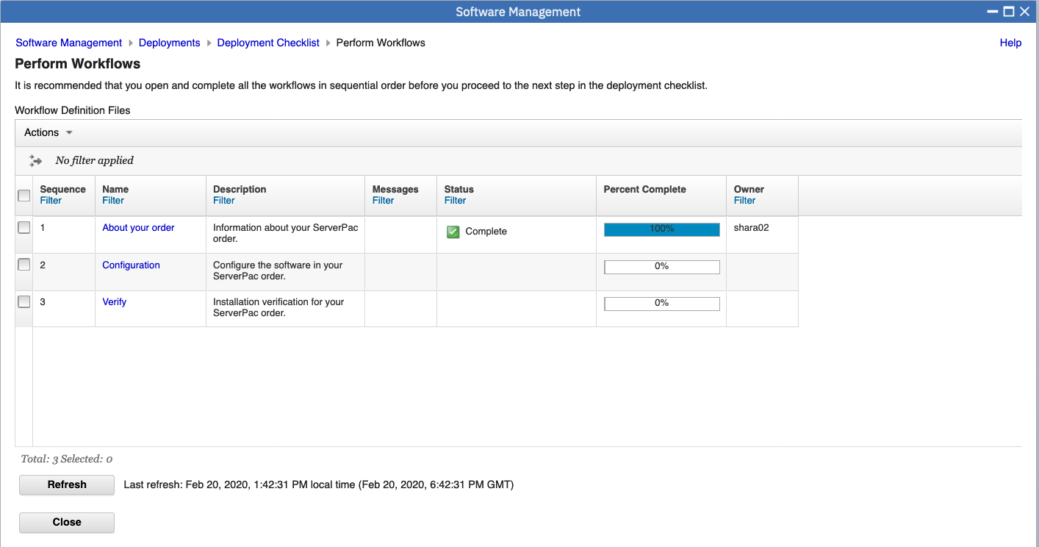

Complete all three workflows if you feel like it. (Note: Some steps will have JCL jobs to run) and click **Close** when you don’t want to do more Workflow tasks...

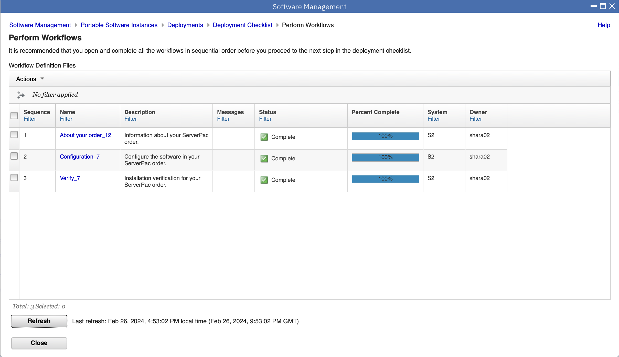

Back on the Deployment Checklist, click on **Specify the properties for the target software instance**.

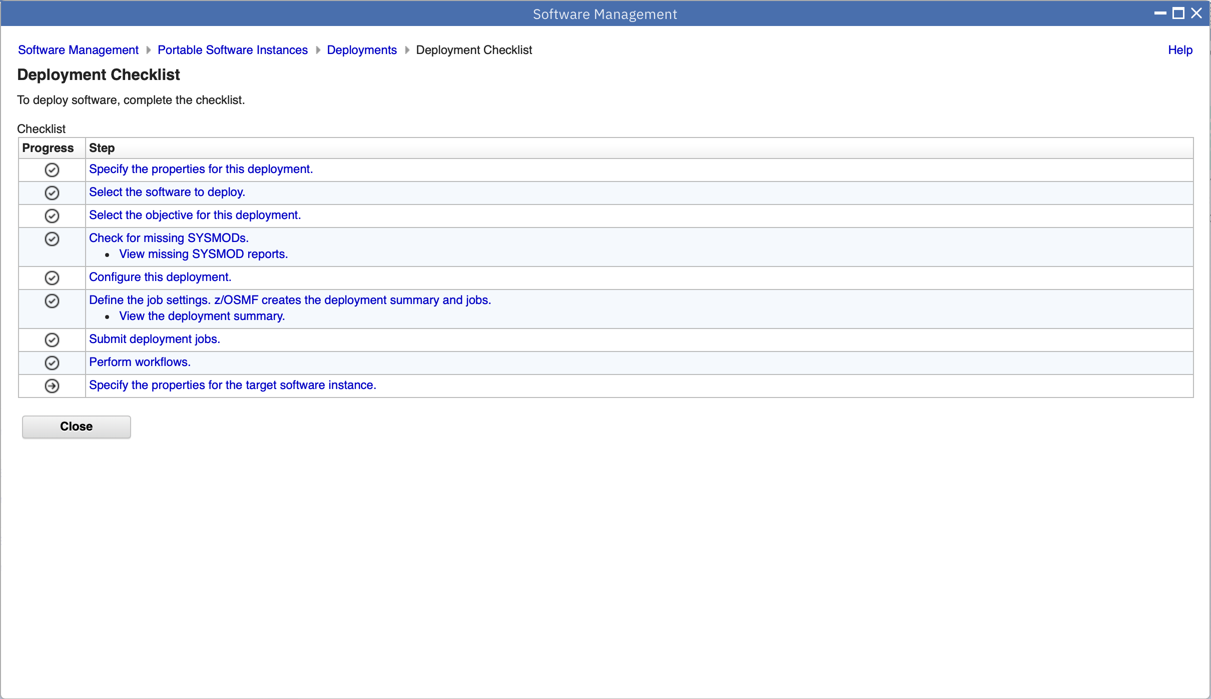

Now that you have this product install, you could give it another software instance name, for instance **<your_userid>-TheBoxIII_PTFs_Install** Click **OK**.

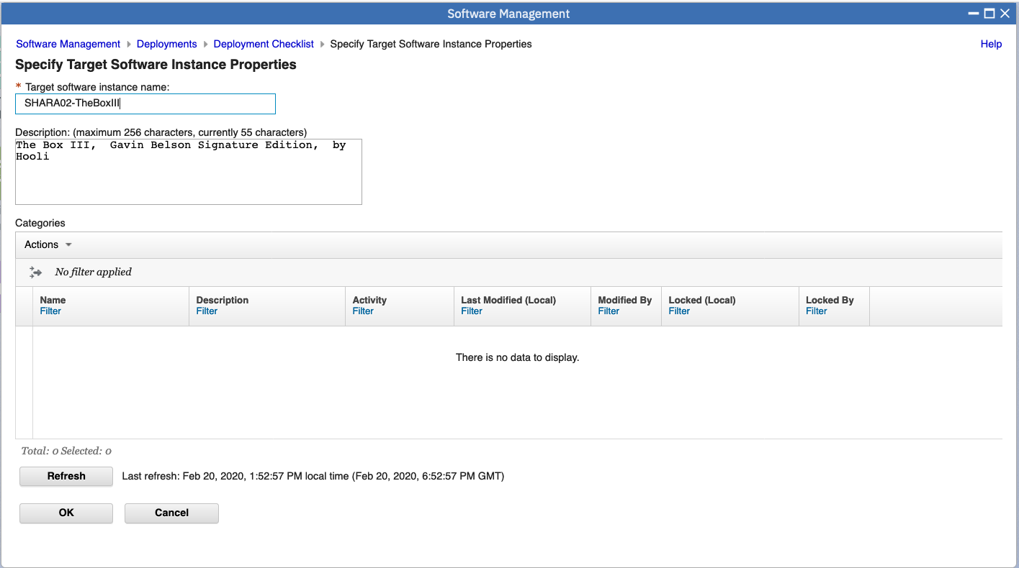

Congratulations!! You have just deployed a Portable Software Instance. You should will now get 3 messages. You can **Close** out of this window.

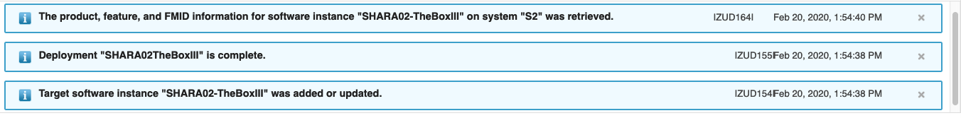

**Clean up**

After you’ve done all the poking around that you like on this deployment, it would be nice of you to delete your deployment you just made to keep unnecessary deployments cleaned off the system. Click on **Deployments**, select your own deployment, then **Actions -> Remove**. (Make sure to check to delete the workflow instances associated with the selected deployment)

From the Software Management window, go back to the **Portable Software Instances**, select your PSI and click **Actions -> Remove**.

Thank you for being a good user on our system!